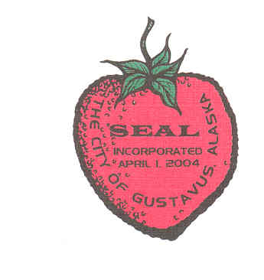

Gustavus CITY COUNCIL

Work Session

September 12, 2017

5:30 pm City Hall

**The Gustavus City Council will be holding a Work Session on Tuesday, September 12**

**at 5:30pm**

**Preschool Proposal to the City of Gustavus**

**The meeting will be held at City Hall.**

**The public is welcome to attend.**

**Gustavus City Council:**

**Mayor (Seat G):**

**Barb Miranda**

**barb.miranda@gustavus-ak.gov**

**Term Expires 2017**

**Vice-Mayor (Seat B):**

**Jake Ohlson**

**jake.ohlson@gustavus-ak.gov**

**Term Expires 2019**

**Council Member (Seat A):**

**Cheryl Cook**

**cheryl.cook@gustavus-ak.gov Expires 2017**

**Council Member (Seat C):**

**Jon Howell**

**[jon.howell@gustavus-ak.gov](mailto:jon.howell@gustavus-ak.gov)**

**Term Expires 2017**

**Council Member (Seat D):**

**Mike Taylor**

**[mike.taylor@gustavus-ak.gov](mailto:mike.taylor@gustavus-ak.gov)**

**Term Expires 2017**

**Council Member (Seat E):**

**Tim Sunday**

**tim.sunday@gustavus-ak.gov**

**Term Expires 2018**

**Council Member (Seat F):**

**Calvin Casipit**

**calvin.casipit@gustavus-ak.gov**

**Term Expires 2017**

**Gustavus City Hall:**

**City Clerk**

**Karen Platt**

**karen.platt@gustavus-ak.gov**

**City Treasurer**

**Phoebe Vanselow**

**Phoebe.vanslow@gustavus-ak.gov**