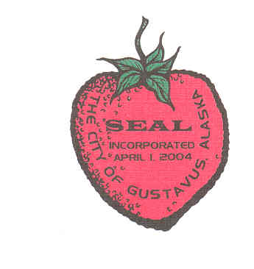

Gustavus CITY COUNCIL

General Meeting

September 11, 2017

7:00 pm City Hall

**AGENDA**

**1. Call to Order**

**2. Roll Call**

**3. Approval of Minutes:**

**A. General Meeting Minutes August 14, 2017**

**4. Mayor’s Request for Agenda Changes**

**5. Department/Committee Reports:**

**A. Marine Facilities**

**6. Public Comment on Non-Agenda Items**

7.Consent Agenda

8. Ordinance for Public Hearing

9. Unfinished Business

**10. New Business:**

**A. Resolution CY18-01 Falls Creek Intertie between the City of Gustavus and Glacier Bay National Park**

**B. Approve Purchase Order for the Road Brushing Project**

**C. Publish FY18-01NCO Providing for the Amendment of the library budget for Fiscal Year 2018.**

**11. Staff Reports**

**A. City Treasurer Report**

12. City Council Reports

**13. City Council Questions and Comments**

**14. Public Comment on Non-Agenda Items**

15. Executive Session

**16. Adjournment**

**Gustavus City Council:**

**Mayor (Seat G):**

**Barb Miranda**

[**barb.miranda@gustavus-ak.gov**](mailto:barb.miranda@gustavus-ak.gov)

**Term Expires 2017**

**Vice-Mayor (Seat B):**

**Jake Ohlson**

**jake.ohlson@gustavus-ak.gov**

**Term Expires 2019**

**Council Member (Seat A):**

**Cheryl Cook**

**cheryl.cook@gustavus-ak.gov**

**Term Expires 2017**

**Council Member (Seat C):**

**Jon Howell**

[**jon.howell@gustavus-ak.gov**](mailto:jon.howell@gustavus-ak.gov)

**Term Expires 2017**

**Council Member (Seat D):**

**Mike Taylor**

[**mike.taylor@gustavus-ak.gov**](mailto:mike.taylor@gustavus-ak.gov)

**Term Expires 2017**

**Council Member (Seat E):**

**Tim Sunday**

**tim.sunday@gustavus-ak.gov**

**Term Expires 2018**

**Council Member (Seat F):**

**Calvin Casipit**

[**calvin.casipit**](mailto:barb.miranda@gustavus-ak.gov)**@gustavus-ak.gov**

**Term Expires 20178**

**Gustavus City Hall:**

**City Clerk:**

**Karen Platt**

**clerk@gustavus-ak.gov**

**Treasurer:**

**Phoebe Vanselow**

**treasurer@gustavus-ak.gov**