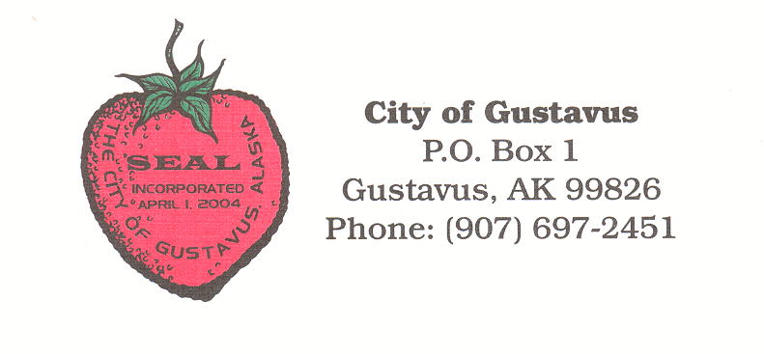

CITY PUBLIC PACKET

May 08, 2017

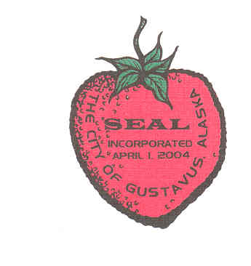

Gustavus CITY COUNCIL

General Meeting

May 8, 2017

7:00 pm City Hall

**AGENDA**

**1. Call to Order**

**2. Roll Call**

**3. Approval of Minutes:**

**A. General Meeting Minutes April 10, 2017**

**4. Mayor’s Request for Agenda Changes**

**5. Department/Committee Reports:**

**A. GVA**

**B. DRC**

**6. Public Comment on Non-Agenda Items**

7.Consent Agenda

8. Ordinance for Public Hearing

9. Unfinished Business

**10. New Business:**

**A. Adopt Resolution CY17-05 Ensuring Continued Administration of Road Maintenance Activities**

**B. Adopt Resolution CY17-06 Amending the DRC Fee Schedule and Material Limitations Policy**

**C. Adopt Resolution CY17-07 Opposing H.R. 232**

**D. Approve posting Road Maintenance RFQ FY18-RM01**

**E. Approve posting Compost Yard Improvement Project RFQ FY17-03DRC**

**F. Approve GVFD Scoping Document for Replacing Engine 34**

**G. Publish FY17-03NCO Providing for the Amendment of the City Held Accounts in Fiscal Year 2017**

**H. Publish FY17-04NCO Providing for the Establishment and Adoption of the Budget for Fiscal Year 2018**

11. Staff Reports

12. City Council Reports

**13. City Council Questions and Comments**

**14. Public Comment on Non-Agenda Items**

15. Executive Session

**16. Adjournment**

**Gustavus City Council:**

**Mayor (Seat E):**

**Tim Sunday**

**tim.sunday@gustavus-ak.gov**

**Term Expires 2018**

**Vice-Mayor (Seat F):**

**Connie Edwards**

[**connie.edwards@gustavus-ak.gov**](mailto:connie.edwards@gustavus-ak.gov)

**Term Expires 2018**

**Vacancy Posted (Seat A):**

**One Year Term Expires 2017**

**Council Member (Seat B):**

**Jake Ohlson**

**jake.ohlson@gustavus-ak.gov**

**Term Expires 2019**

**Council Member (Seat C):**

**Jon Howell**

[**jon.howell@gustavus-ak.gov**](mailto:jon.howell@gustavus-ak.gov)

**Term Expires 2017**

**Council Member (Seat D):**

**Mike Taylor**

[**mike.taylor@gustavus-ak.gov**](mailto:mike.taylor@gustavus-ak.gov)

**Term Expires 2017**

**Council Member (Seat G):**

**Barb Miranda**

**barb.miranda@gustavus-ak.gov**

**Term Expires 2017**

**Gustavus City Hall:**

**City Clerk/Treasurer**

**City Administrator:**

**Lori Ewing**

**lori.ewing@gustavus-ak.gov**

**Administrative Assistant:**

**Tanya Wagner**

**tanya.wagner@gustavus-ak.gov**

**Item No. 1 Call to Order**

**Item No. 2 Roll Call**

**Item No. 3 Approval of Minutes**

**A. Minutes of April 10, 2017 General Meeting**

**GUSTAVUS CITY COUNCIL**

**GENERAL MEETING MINUTES**

**April 10TH, 2017**

**1.** **CALL TO ORDER:**

A General Meeting of the Gustavus City Council is called to order on April 10th, 2017, at 7:01pm by Vice Mayor Edwards. There are ten (10) members of the public in attendance at Gustavus City Hall.

**2**. **ROLL CALL:**

Comprising a quorum of the City Council the following are present:

Vice Mayor Edwards

Council Member Taylor

Council Member Howell

Council Member Ohlson

The following members are not present:

Mayor Sunday *excused*

Council Member Miranda *excused*

**3. APPROVAL OF MINUTES:**

**A. General Meeting Minutes March 13th, 2017**

MOTION: Council Member Howell moves to approve the General Meeting Minutes from March 13th, 2017, as presented.

SECONDED BY: Council Member Taylor

PUBLIC COMMENT: None

ROLL CALL VOTE ON MOTION:

**YES:** Edwards, Taylor, Howell, Ohlson

NO:

RECUSED:

MOTION **PASSES**/FAILS **4**/0

**4.** **MAYOR'S REQUEST FOR AGENDA CHANGES: None**

**5. COMMITTEE REPORTS:**

**A. GVFD – report given by T. Miller**

**B. Library – report given/submitted by B. Ohlson**

**6. PUBLIC COMMENT ON NON-AGENDA ITEMS:**

A. L. Cacioppo – Black smoke burning

B. S. Brook – response to GCC letter

7. CONSENT AGENDA

8. ORDINANCE FOR PUBLIC HEARING

9. UNFINISHED BUSINESS

**10. NEW BUSINESS:**

**A. Approve Marine Facilities Coordinator Position Description and Announcement**

MOTION: Council Member Howell moves to Approve the Marine Facilities Coordinator Position Description and Announcement

SECONDED BY: Council Member Taylor

PUBLIC COMMENT: None

ROLL CALL VOTE ON MOTION:

**YES:** Edwards, Taylor, Howell, Ohlson

NO:

RECUSED:

MOTION **PASSES**/FAILS **4**/0

**B. Adopt Resolution CY17-04 Providing for a Cost of Living Pay Adjustment for City of Gustavus Employees in Regular Positions**

MOTION: Council Member Ohlson moves to Adopt CY17-04 Providing for a Cost of Living Pay Adjustment for City of Gustavus Employees in Regular Positions

SECONDED BY: Council Member Howell

PUBLIC COMMENT: None

ROLL CALL VOTE ON MOTION:

**YES:** Edwards, Taylor, Howell, Ohlson

NO:

RECUSED:

MOTION **PASSES**/FAILS **4**/0

11. STAFF REPORTS

12**.** CITY COUNCIL REPORTS

**13. CITY COUNCIL QUESTIONS AND COMMENTS:**

A.M. Taylor – Project at Grandpa’s Farm Road, grant request due May 9

**14. PUBLIC COMMENT ON NON-AGENDA ITEMS:** None

15. EXECUTIVE SESSION

**16. ADJOURNMENT:**

Hearing no objections, Vice Mayor Edwards adjourns the meeting at 7:50pm.

**Item No. 4 Mayor's Request for Agenda Changes**

**Item No. 5. Department/Committee Reports:**

**A. GVA**

**B. DRC**

**A. GVA Report**

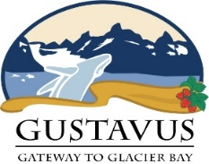

**GVA – First Quarter 2017 (January – March, 2017)**

The first quarter of the calendar year is the Gustavus Visitors Association’s second quarter of our fiscal year. We currently have 43 member businesses and 13 complimentary listings. The GVA board approved raising the advertised wage rate for our administrator position in hopes of hiring an administrator for the current year. The position was then filled in mid-March, and we are very glad to announce that Katelyn Tippery is our new administrator. She has well rounded experience working in the tourism industry in Gustavus and Glacier Bay and we feel your skill set will be a very good fit for the GVA administrator position. With the uncertainty of a consistent funding stream from the City our ability to secure and keep an administrator employed is questionable. Our updated Marketing Plan along with our approved 2017-2018 Budget was submitted to the City of Gustavus at the end of February. Our current board of directors is active and working hard to move the GVA forward in its relationship with the City of Gustavus. We were grateful for the meeting we held with the City Council in March regarding the 2017 map brochure and look forward to a follow up meeting in April when the City Council is able to secure a workable date. Once the City Council and the GVA agreed upon an updated map brochure we started our 2017 membership with an end date of April 15 in order to make sure we have time to edit and finalize the map brochure in time for printing by May.

**Advertising and Travel Shows**

Advertising for the 2017 has continued in this quarter and both print and electronic ads were secured. We ran an ad with the Alaska Airlines Magazine, Google Ad Words, along with securing booths for both the JCVB Travel Fair and the Meritime Festival in Juneau.

**Membership activities:**

**ATIA – Statewide Alaska Travel Industry Association, Managed by DCCED**

The GVA has continued to work this Quarter to refine and expand our reach via the TravelAlaska website and Travel Planning Guide presence and receives special marketing/advertising opportunities by being a member of this statewide organization.

**JCVB – Juneau Convention and Visitors Bureau**

By being a member of JCVB we are able to take advantage of many discounts and cooperative marketing opportunities along with networking opportunities and presence at travel shows attended by and thrown by the JCVB

**GVA Website:** [www.gustavusak.com](http://www.gustavusak.com)

Activity on our website has picked up this quarter. We have approximately 20-30 visits to our website a day. Our administrator has been updating it with current pictures and information from our members as they roll in.

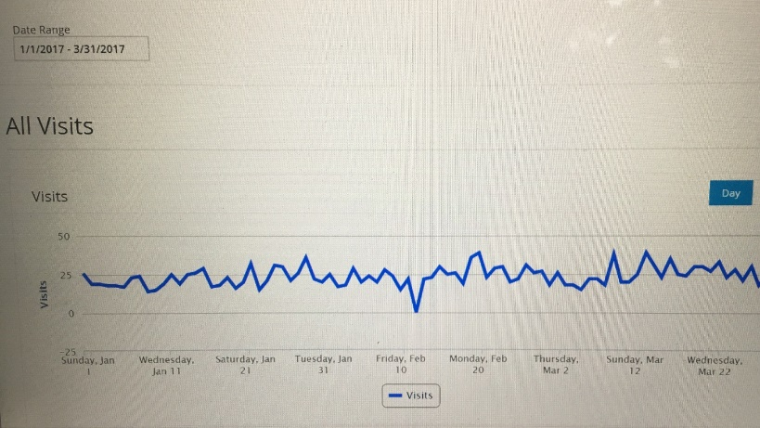

**Mobile Visits Segregated:**

Mobile visits to our website are very prevalent and continued updates and tweaking of our website are needed to help insure that mobile visits continue to increase as well. Between the dates of 1/1/17-3/31/17, we received 560 mobile and tablet visits.

**Social Media: Facebook**

The Gustavus Visitors Association has not been able to keep up our Facebook presence as much as desired with the lack of an administrator but are very excited to have filled that position in March. We are getting back on track with putting a large amount of time into continuing to building our Facebook presence. There has been a steady increase in our Facebook traffic and we hope that gain in exposure will translate into increased interested in our community. This is a very hard conversion rate to translate with people frequenting Facebook but not necessarily booking through Facebook.

**GVA Members:**

The GVA Membership year is our fiscal year October 1st through September 30th. We started our membership drive for 2017 in March 2017 after our meeting with the City Council in regards to how we were going to move forward with our map brochure. Below is the list of businesses that are current and appear on our website and in our brochure and maps. We have 43 current members at this time with 13 complimentary members:

**Conclusion:**

We are encouraged by the upcoming season and are geared to attend the Travel Juneau Travel Show in April and the Maritime Festival in May. Both events are held in Juneau and are a great opportunity for us to actively promote Gustavus and Glacier Bay to the extensive Juneau tourism market and potential visitors. We are working with the National Park Service to promote the Totem Raising Event in May along with updating the information they provide at the dock kiosk and present for us at the back country station in Bartlett Cove. We are hopeful that the City of Gustavus will provide information for the kiosk at the dock as has been requested. Even though we are worried about the uncertainty of funding from the City, we continue to promote Gustavus and Glacier Bay to visitors regionally, country wide, and globally. Our combined efforts, with the City of Gustavus, regional and statewide DMOs, Glacier Bay National Park, and our tourism entities to continue to promote our small unique community both through advertising and actions items in our community is our highest priority. The Gustavus Visitors Association encourages questions and comments from our community members and from our City Council.

**Item No. 6 Public Comment on Non-Agenda Items**

Item No. 8. Ordinance for Public Hearing

Item No. 9. Unfinished Business

**Item No. 10. New Business:**

**A. Adopt Resolution CY17-05 Ensuring Continued Administration of Road Maintenance Activities**

**CITY OF GUSTAVUS, ALASKA**

**RESOLUTION CY17-05**

**A RESOLUTION ENSURING CONTINUED ADMINISTRATION OF ROAD MAINTENANCE ACTIVITIES**

**WHEREAS,** the City of Gustavus provides road maintenance services within the city limits for all constructed, publicly dedicated roadways except those maintained by the State of Alaska Department of Transportation and Public Facilities or by the U.S. Department of the Interior, National Park Service); and,

**WHEREAS,** The Gustavus City Council adopted Title 6, Boards and Commissions Ordinance which includes the establishment of the Road Committee (Section 6.04.030); and,

**WHEREAS,** Section 6.04 further instructs that the Roads Committee is to oversee, budget and direct road maintenance activities including payments to contractors, develop road maintenance standards for inclusion in contracts and for posting on the City website, prepare road maintenance RFQs, select road maintenance contractors, and determine road maintenance requirements and monitor such activities; and,

**WHEREAS,** the current Roads Committee has no chairperson and is essentially defunct; and,

**WHEREAS,** the City has the responsibility to continue the administration of the road maintenance activities listed above.

**NOW THEREFORE BE IT RESOLVED THAT**, the City of Gustavus Roads Committee is temporarily suspended until such time that public interest allows for its customary role or the City determines the committee is no longer necessary; and,

**BE IT FURTHER RESOLVED**, during the Committee’s temporary suspension, and/or upon dissolution, road maintenance activities (which includes overseeing, budgeting and directing road maintenance activities including payments to contractors, developing road maintenance standards for inclusion in contracts and for posting on the city web site, preparing road maintenance RFQs, selecting road maintenance contractors, and determining road maintenance requirements and monitoring such activities) will be conducted by the Mayor and/or the City Administrator.

**Passed** and **approved** by the Gustavus City Council this 8th day of May, 2017, and effective upon adoption.

________________________________________

Tim Sunday, Mayor

________________________________________

Attest: Lori Ewing, CMC

City Clerk/Treasurer

Lori Ewing, CMC

**B. Adopt Resolution CY17-06 Amending the DRC Fee Schedule and Material Limitations Policy**

**CITY OF GUSTAVUS, ALASKA**

**RESOLUTION CY17-06**

**A Resolution Amending the Gustavus Disposal & Recycling Center (DRC) Fee Schedule and Material Limitations Policy**

**WHEREAS,** DRC fee schedule was last updated at the May 11, 2015, General Meeting with Resolution CY15-17; and,

**WHEREAS,** the DRC Manager has requested the amendment Resolution CY17-06 to address cost increases in providing DRC's extensive recycling and waste disposal services to the community. Changes to the fee structure represent a roughly 5% fee increase from the previous fee schedule for most items and a 50¢ increase in the minimum charge (New rate $3.50);

**NOW THEREFORE BE IT RESOLVED** that the Gustavus City Council approves the amended “Gustavus Disposal & Recycling Center (DRC) Fee Schedule and Materials Limitation Policy,” a copy of which is attached as Exhibit A. The new fee schedule shall become effective on Tuesday May 23rd, 2017.

**Passed** and **approved** by the Gustavus City Council this 8th day of May, 2017, and effective upon adoption.

________________________________________

Tim Sunday, Mayor

________________________________________

Attest: Lori Ewing, CMC

City Clerk/Treasurer

**EXHIBIT A**

**Gustavus Disposal & Recycling Center (DRC)**

**2017-18 Fee Schedule and Material Limitations Policy**

**What is free:**

* Aluminum pop & beer cans
* Non-ferrous metals such as: copper (house wire, plumbing pipe), aluminum (foil, cookware, roofing etc.), brass (faucets, valves, fittings) & non-magnetic stainless steel.
* Litter from local roadsides and beaches *(collection bags can be provided)*

**Rate schedule:**

**General**

* Recyclables $0.19 per pound
* Trash $0.24 per pound
* Unsorted waste **PENALTY RATE** $0.41 per pound

**Special**

* Computer Monitors, & TV's $0.60 per pound
* Grease trap waste $0.58 per pound
* Construction/demo. or ash $5.90 per 32 gal. Can or $38.35 per yard
* Sheetrock $2.90 per 32 gal. Can or $18.85 per yard
* Fluorescent tube bulbs $1.30 each
* Freezer, refrigerator etc. $40.00 per appliance (plus weight of appliance)

**$3.50 minimum** per delivery *(items listed as free do not count)*

**Items included in recycle category:**

Aluminum, cardboard, cooking oil, dry cell batteries, food waste, glass bottles, lead-acid batteries, mixed paper, oil filters, plastics (types 1 -7 only), pottery/ceramics, scrap metal (see exclusions), tin cans, used oil (see exclusions), white sheet paper

**Exclusions & Limitations:**

**Construction/ demolition waste limits:**

There is a 12 yard per year limit on how much construction/demolition (C/D) waste can be delivered by a business or individual. The purpose of this limit is to keep a few users from filling the C/D disposal area in a short period of time. The DRC can assist users to obtain a dumpster from Arrow Refuse in Juneau.

**Scrap metal limitations:**

Due to storage concerns, the DRC will not accept large scrap metal items such as cars, 270 gallon oil tanks or other scrap metal that cannot be easily baled or palletized for recycling.

**Used-oil limitations:**

Due to permit and legal requirements the DRC cannot accept used oil from commercial sources.

Compost Prices: $18.25 per 30-gallon trash can, $4.00 per 5-gallon bucket

Misc. Fees: Pick-up fee for U.S.P.O. & Gustavus School $27.50

**C. Adopt Resolution CY17-07 Opposing H.R. 232**

**City of Gustavus, Alaska**

**RESOLUTION CY17-07**

**A RESOLUTION OPPOSING H.R. 232 (*A BILL AUTHORIZING STATES TO SELECT AND ACQUIRE CERTAIN NATIONAL FOREST SYSTEM LANDS TO BE MANAGED AND OPERATED BY THE STATE FOR TIMBER PRODUCTION AND OTHER PURPOSES UNDER THE LAWS OF THE STATE*)**

**WHEREAS,** H.R. 232, seeks to transfer up to two million acres of Tongass National Forest to the State of Alaska, including surface lands, subsurface lands, and real property (including all roads, public-use cabins, and campgrounds currently owned and operated by the U.S. Forest Service); and

**WHEREAS,** the Tongass National Forest was created by Presidential Proclamation on September 10, 1907 and is managed by the U.S. Forest Service under the multiple-use concept to provide a variety of products and recreational and subsistence opportunities with the long-term goal of protecting the land and its productivity for future generations; and

**WHEREAS,** the City of Gustavus recognizes the need for a local value-added forest products industry that has a reliable and truly sustainable supply of timber accessible from the Tongass National Forest’s existing road system and that does not jeopardize the integrity of the old-growth forest or inhibit other uses of the forest; and

**WHEREAS,** the Tongass National Forest lands at east of Excursion Inlet, on the flightpath/ferry route between Gustavus and Juneau, will be transferred to the State under H.R. 232; and

**WHEREAS,** these lands were heavily logged during the 1980s and have shown very poor regrowth; and

**WHEREAS,** the intent of H.R. 232, as stated in the bill’s language, is “primarily for timber production pursuant to the State forest practices law” and additional logging will further degrade an already degraded landscape; and

**WHEREAS,** the State of Alaska currently faces a budget crisis of over three billion dollars, which has resulted in a hiring freeze; and

**WHEREAS,** while Alaska’s state forest timber program in 2014 lost nine dollars for every dollar spent; and

**WHEREAS,** acquiring more lands for timber production will likely increase the State’s financial losses; and

WHEREAS, under federal law, the U.S. Forest Service must manage the Tongass National Forest for multiple use, including outdoor recreation, hunting, and fishing; and

**WHEREAS,** the timber-first approach to state forest management under the Alaska Forest Resources and Practices Act lacks any limits on the size of clearcuts, provides only minimal salmon habitat protection, and lacks any protections for wildlife habitat; and

**WHEREAS,** if logging under the auspices of the State of Alaska does occur, the State’s policy of allowing unrestricted export of unprocessed logs will do nothing to enhance the wood processing industry in our region and will minimize employment of Alaskans; and

**WHEREAS,** the two-million-acre reduction of federal ownership on the Tongass National Forest proposed by H.R. 232 will likely reduce Payment in Lieu of Taxes (PILT) and Secure Rural Schools (SRS) receipts for Southeast Alaska and will probably reduce payments to the City for roads and schools; and

**WHEREAS,** the Tongass National Forest lands proximate to Gustavus are important to many local businesses and to residents' lifestyles; and

**WHEREAS,** transferring ownership of major portions of the Tongass National Forest to the State of Alaska will create uncertainty and risk for business owners; and

**WHEREAS**, this carte blanche transfer of ownership of major portions of the Tongass National Forest to the State of Alaska gives the State the right to sell or dispose in some way highly productive lands that are in the national interest to maintain as national forest.

**NOW THEREFORE BE IT RESOLVED** that the City of Gustavus favors maintaining the Tongass National Forest in its entirety together and intact under the stewardship of the U.S. Forest Service; and

**BE IT FURTHER RESOLVED,** the City of Gustavus opposes H.R. 232.

**PASSED** and **APPROVED** by the Gustavus City Council, this 8th day of May, 2017, and effective upon adoption.

_______________________________________

Tim Sunday, Mayor

_______________________________________

Attest: Lori Ewing, CMC

City Clerk/Treasurer

**D. Approve posting Road Maintenance RFQFY18-RM01 (Available for Review)**

**E. Approve posting Compost Yard Improvement Project RFQ FY17-03DRC (Available for Review)**

**F. Approve GVFD Scoping Document for Replacing Engine 34 (Available for Review)**

**G. Publish FY17-03NCO Providing for the Amendment of the City Held Accounts in Fiscal Year 2017**

**CITY OF GUSTAVUS, ALASKA**

**Ordinance FY17-03NCO**

**AN ORDINANCE FOR THE CITY OF GUSTAVUS PROVIDING FOR THE AMENDMENT OF THE CITY-HELD ACCOUNTS FOR FISCAL YEAR 2017**

**BE IT ENACTED BY THE GUSTAVUS CITY COUNCIL AS FOLLOWS:**

**Section 1.** Classification. This is a **Non-Code Ordinance**

**Section 2.** For the fiscal year of 2017 the following City-held account balance transfers to be made for reasons stated in each transfer.

**Section 3.** The current fiscal year the account balances are amended to reflect the changed estimates as follows:

**ACCOUNTS:** Account Balance* Amended Budget Change

*\*Approximate, this is a dynamic value*

Northrim Bank $124,334.04 $ 0.00 $ (124,334.04)

*Closes the account*

AMLIP - GVFD $ 783.80 $ 0.00 $ (783.80)

*Closes the account*

CP17-01GVFD $ 0.00 $ 125,117.84 $ 125,117.84

*Funds replacing Engine 34 Capital Project*

Total Change in Account Balances **$ 0.00**

**ACCOUNTS:**

AMLIP - DRC $ 62,843.15 $ 13,843.15 $ (49,000.00)

*Resolution FY17-03*

CP17-03DRC $ 0.00 $ 49,000.00 $ 49,000.00

*Funds Compost Yard Improvement Capital Project*

Total Change in Account Balances **$ 0.00**

**Section 4.** The City-held accounts are hereby amended as indicated.

**Section 5.** Effective Date. This ordinance becomes effective upon its adoption by the Gustavus City Council.

**DATE INTRODUCED:** *May 8, 2017*

**DATE OF PUBLIC HEARING:***June 12, 2017*

**PASSED** and **APPROVED** by the Gustavus City Council this ____ day of ___________, 2017.

________________________________________

Tim Sunday, Mayor

________________________________________

Attest: Lori Ewing, CMC

City Clerk/Treasurer

**H. Publish FY17-04NCO Providing for the Establishment and Adoption of the Budget for Fiscal Year 2018**

**CITY OF GUSTAVUS, ALASKA**

**ORDINANCE FY17-04NCO**

**AN ORDINANCE FOR THE CITY OF GUSTAVUS PROVIDING FOR THE ESTABLISHMENT AND ADOPTION OF THE BUDGET FOR FISCAL YEAR 2018**

**BE IT ENACTED BY THE CITY OF GUSTAVUS AS FOLLOWS:**

**Section 1.** Classification. This is a **Non-Code Ordinance.**

**Section 2.** General Provisions. The attached document is the authorized budget of revenues and expenditures for the period July 1 through June 30 and is made a matter of public record.

**Section 3.** Effective Date. This ordinance becomes effective upon its adoption by the City Council.

**DATE OF PUBLICATION:** *May 08, 2017*

**DATE OF PUBLIC HEARING:** *June 12, 2017*

**PASSED** and **APPROVED** by the Gustavus City Council this ___ day of _________, 2017.

______________________________________

Tim Sunday, Mayor

__________________________________

Attest: Lori Ewing, CMC

City Clerk/Treasurer

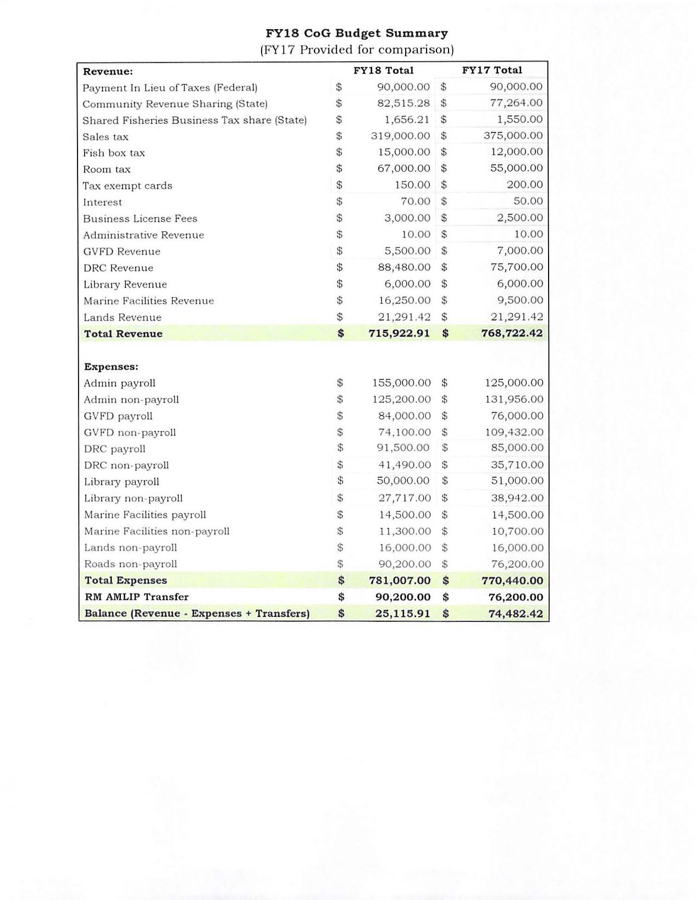

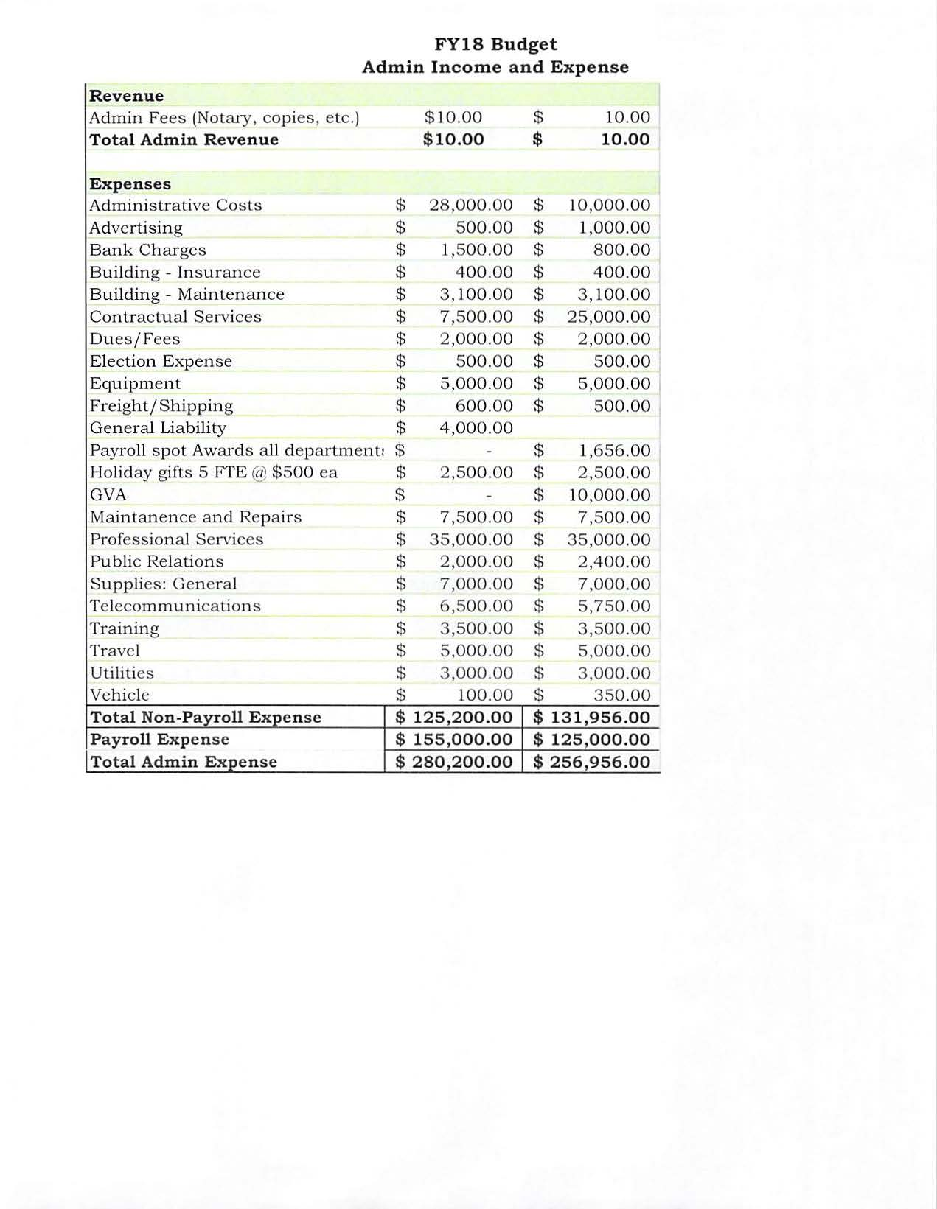

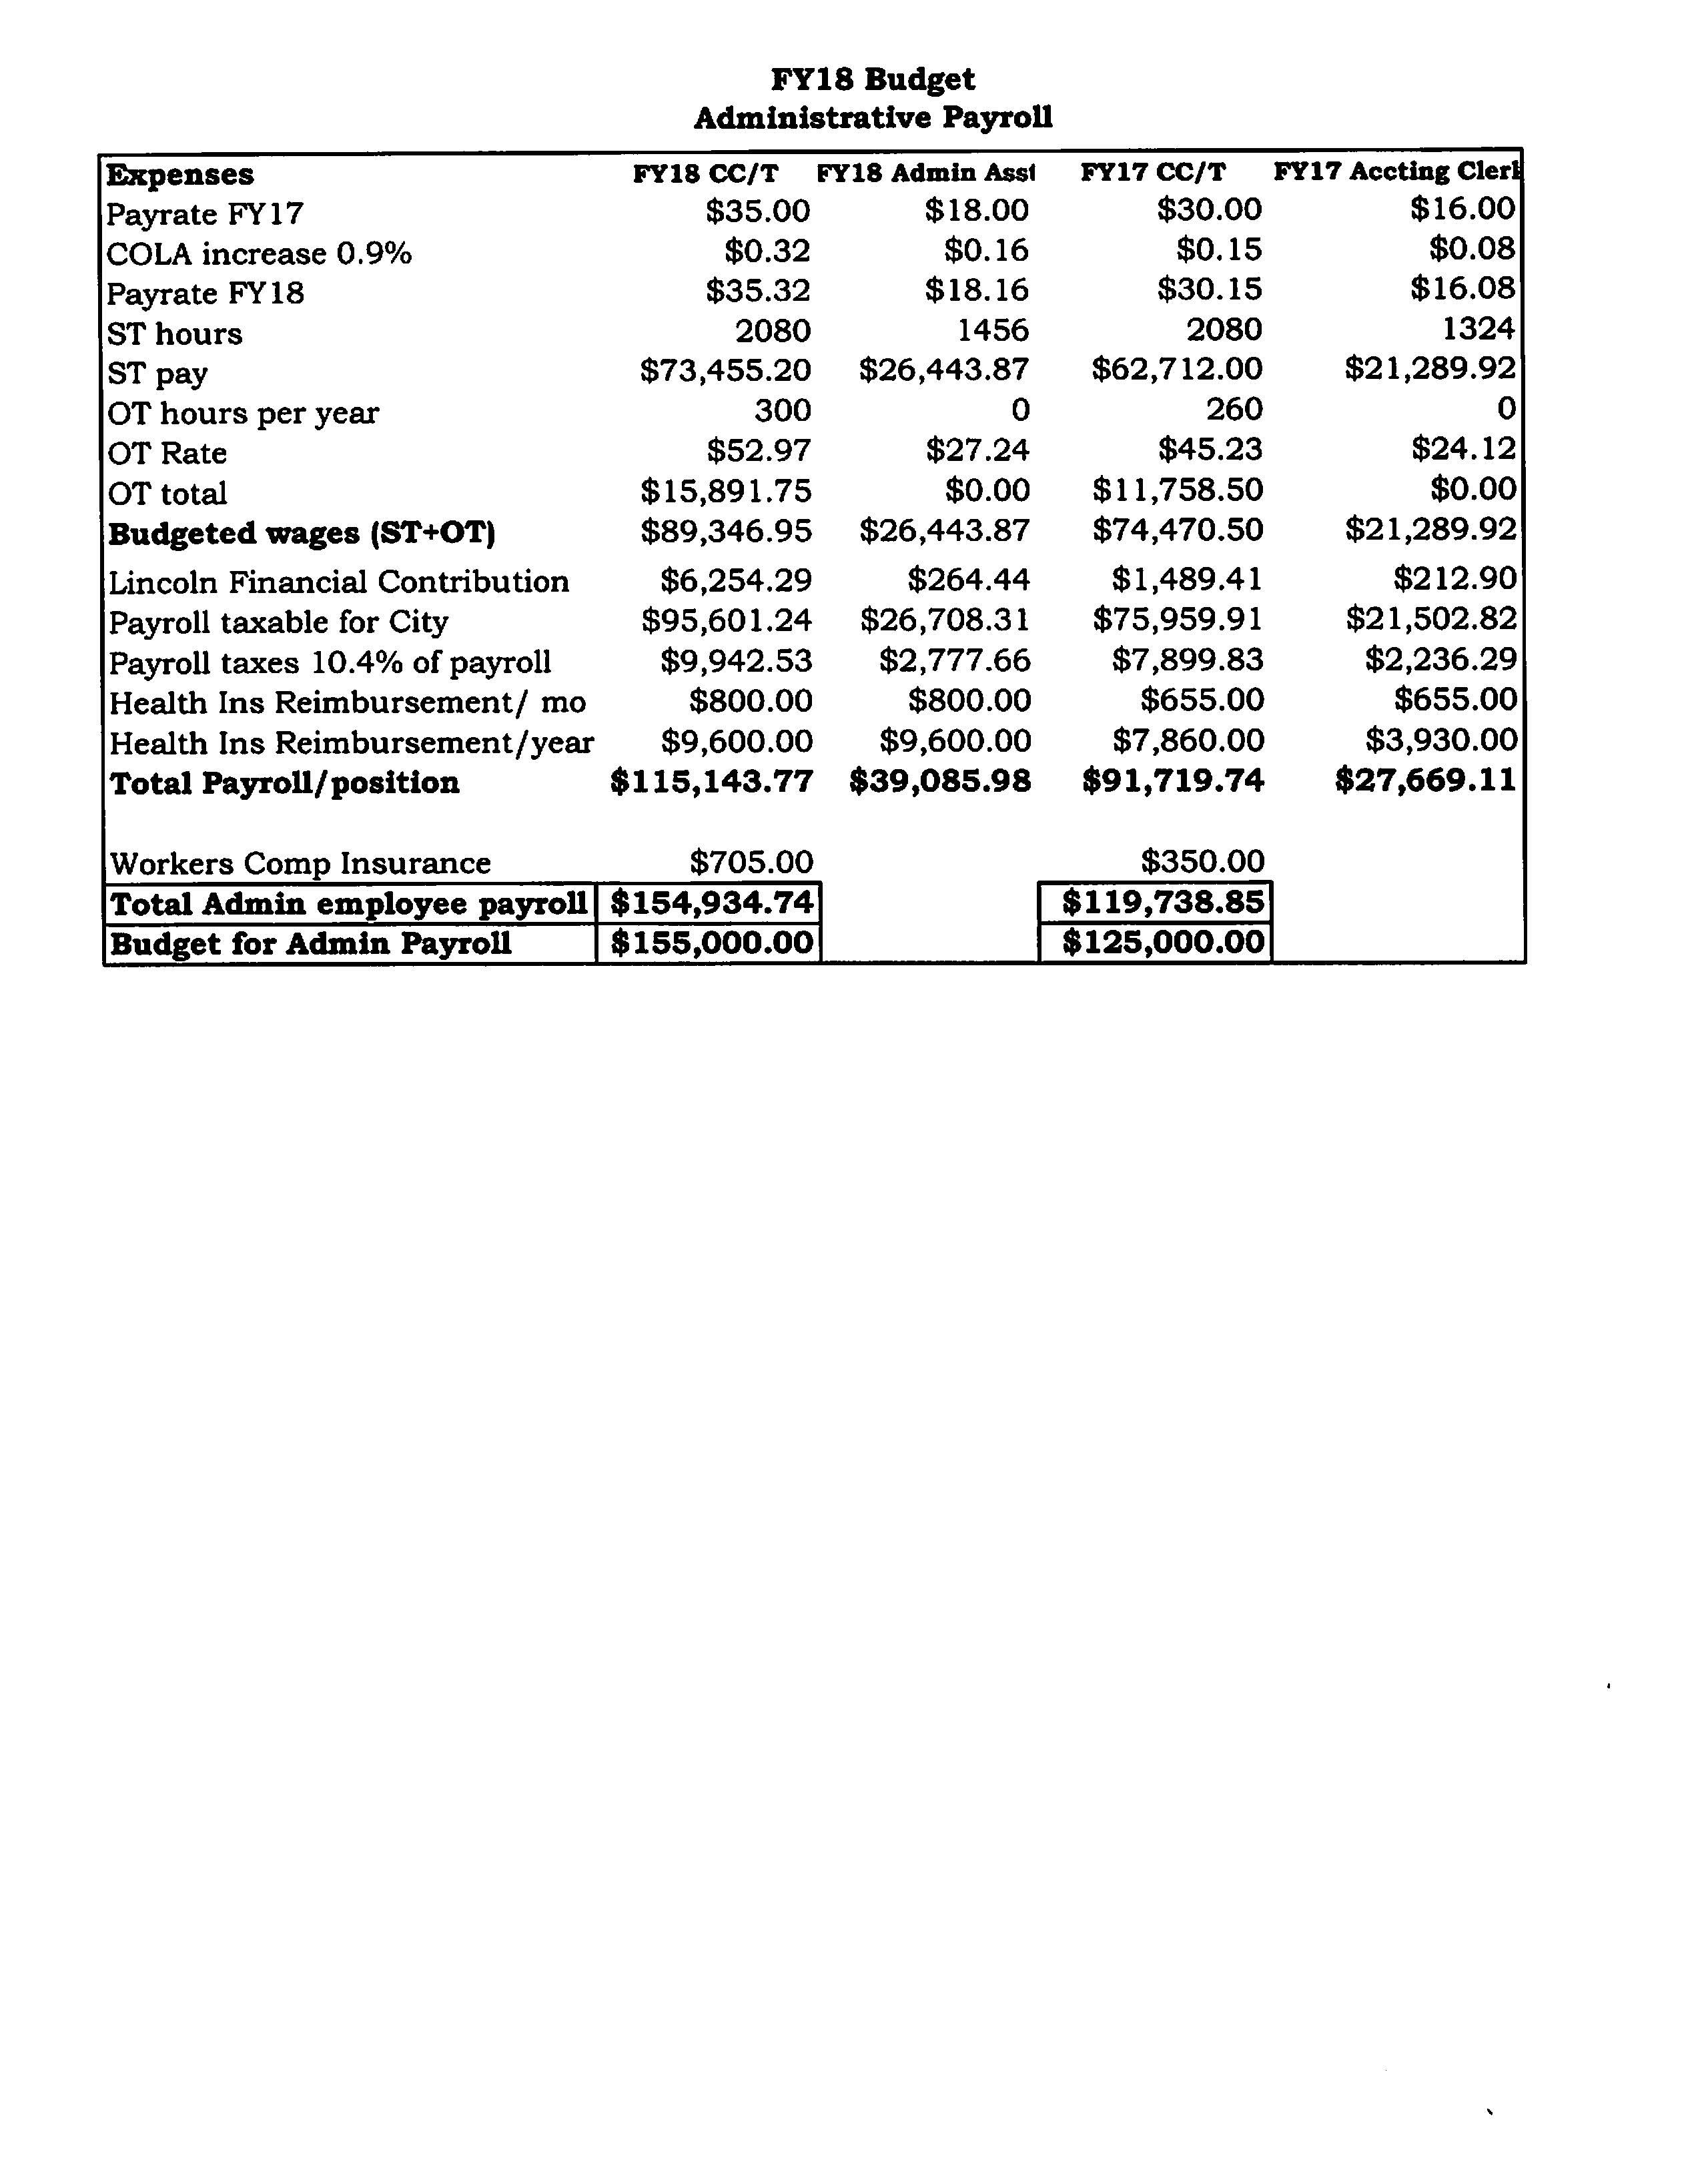

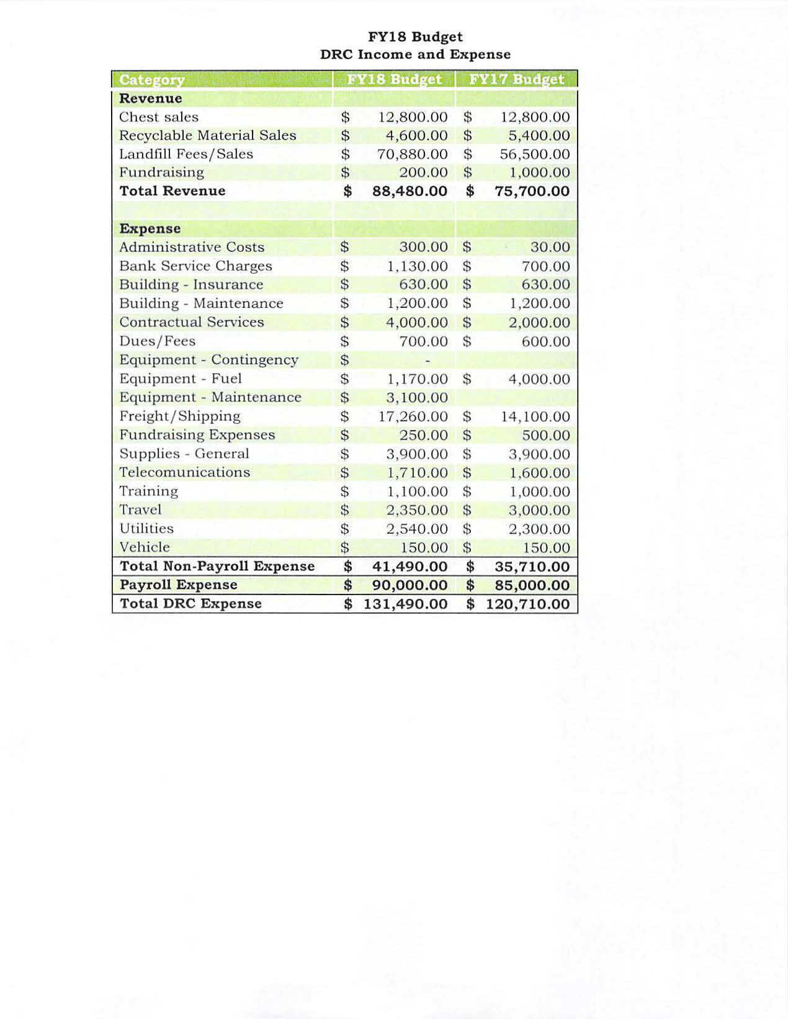

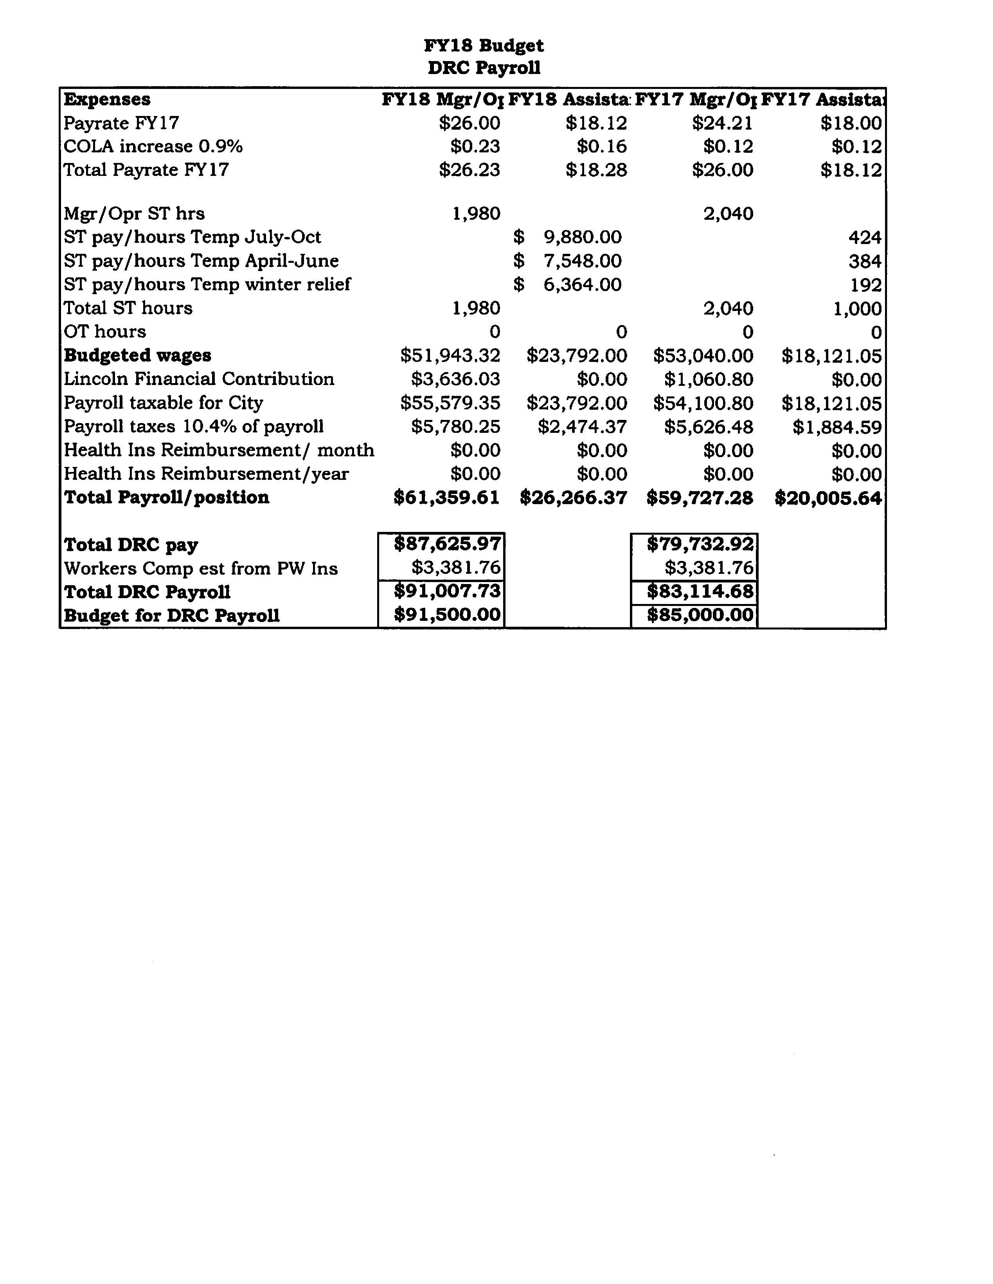

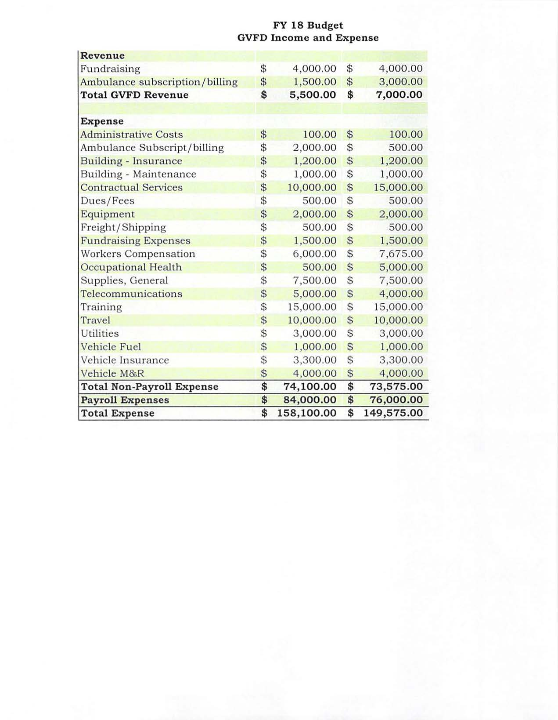

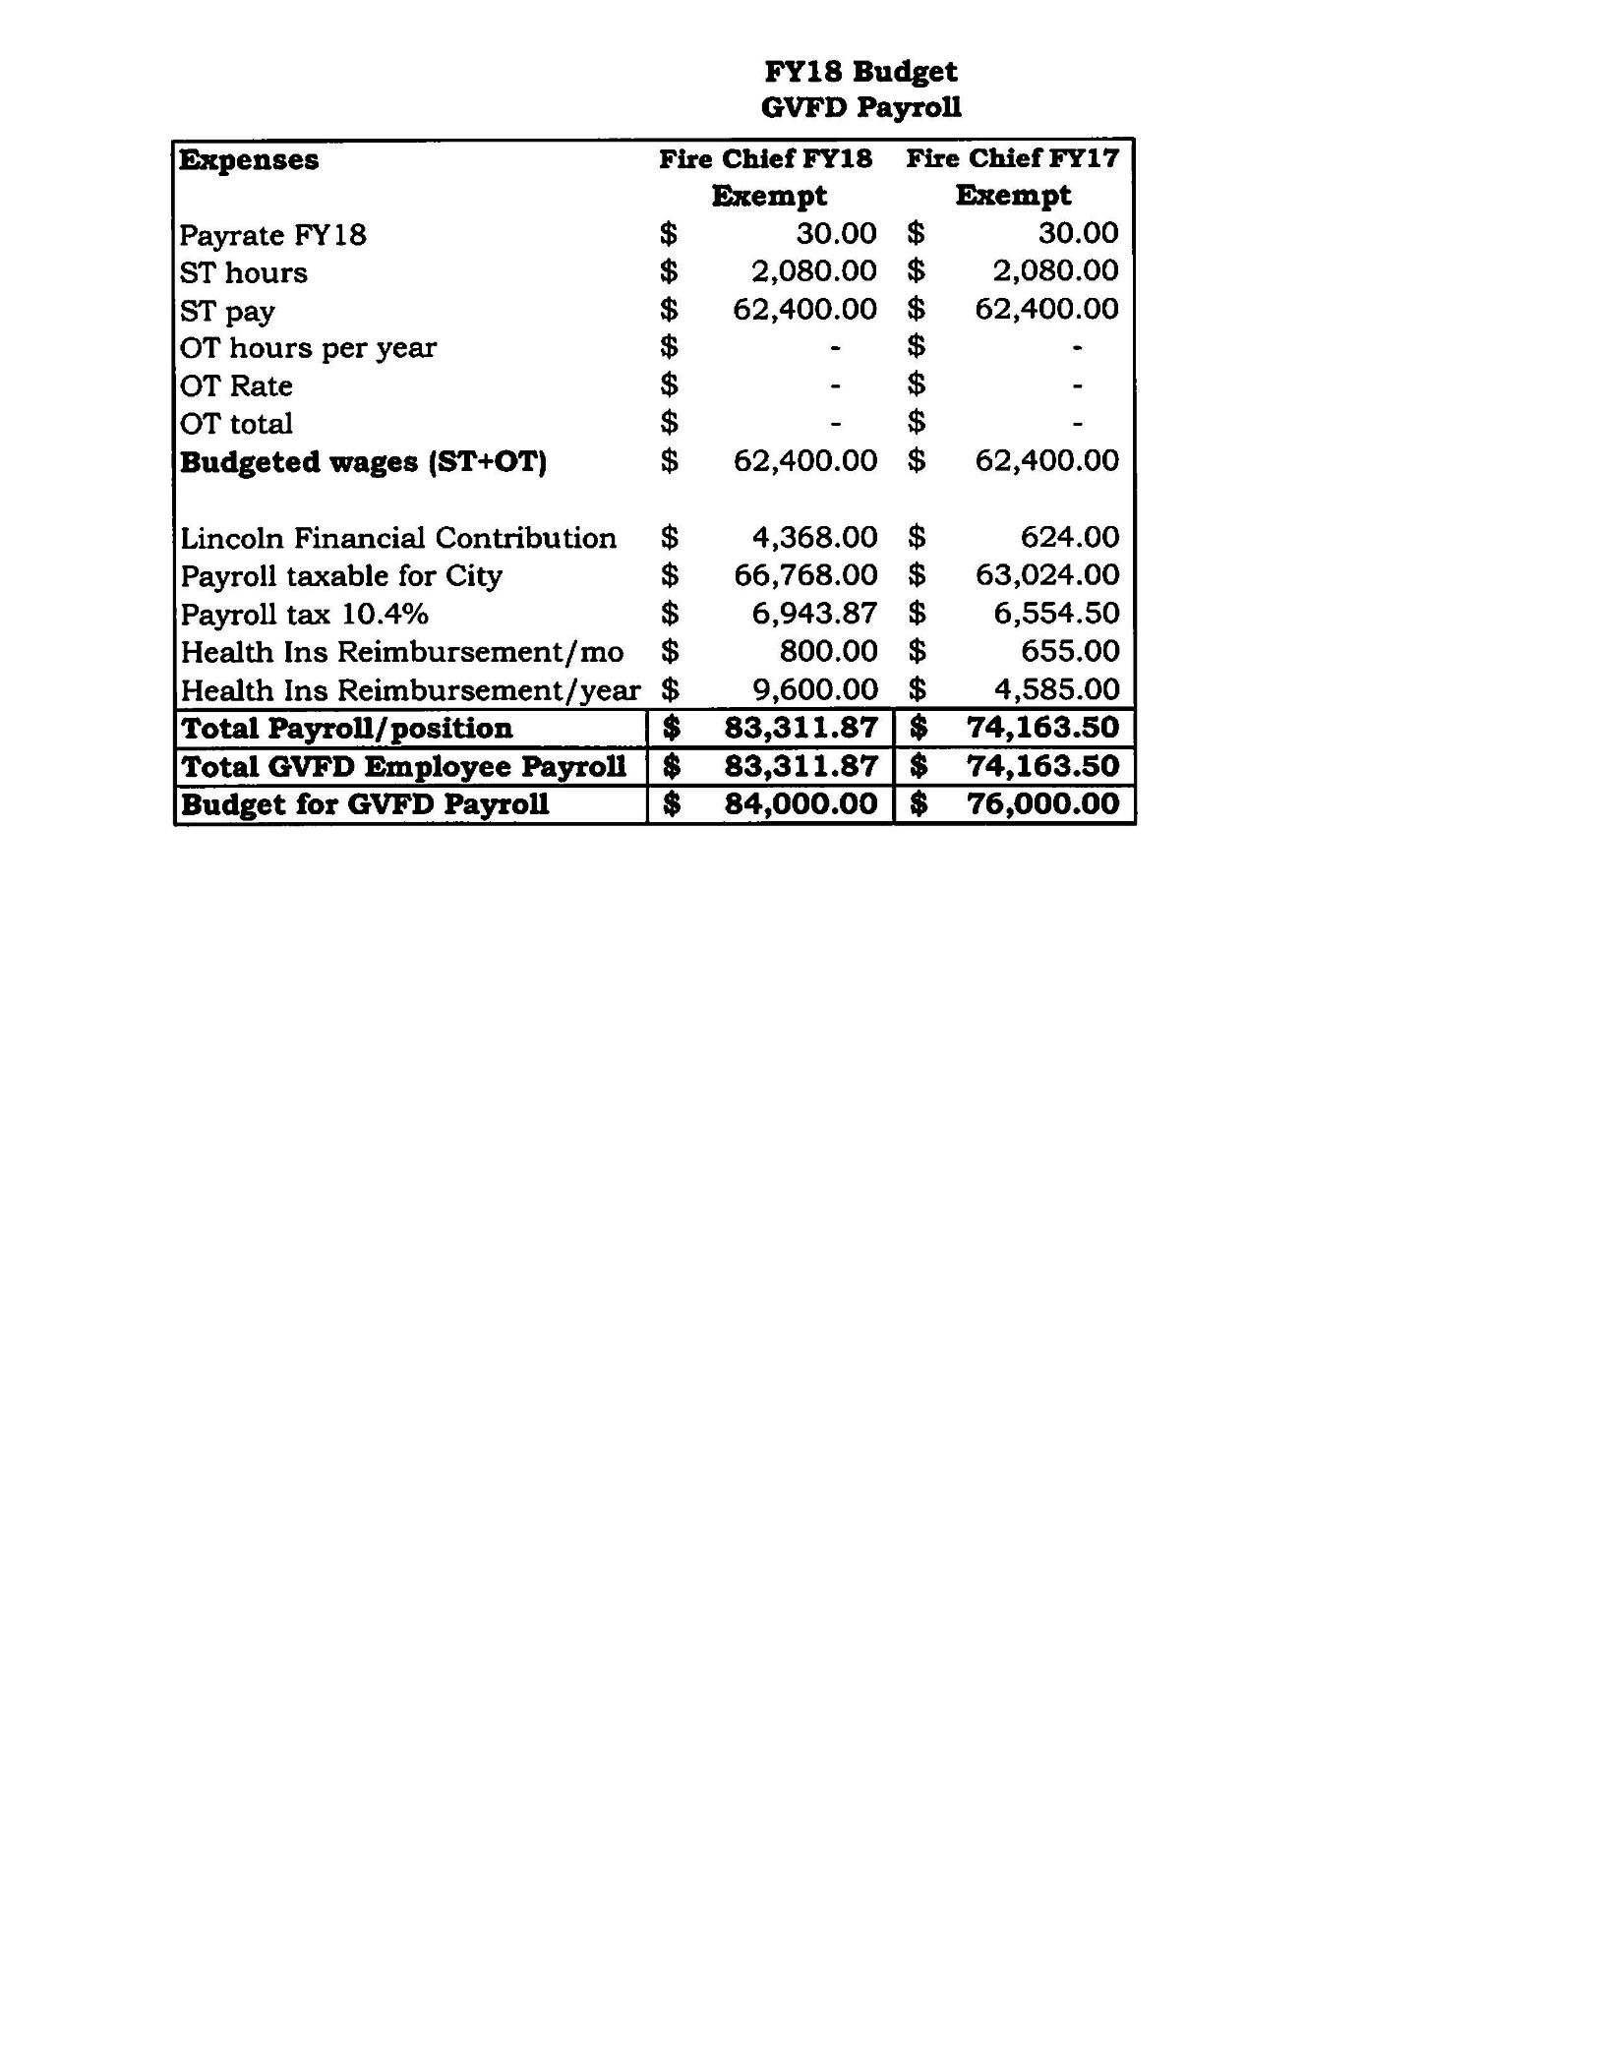

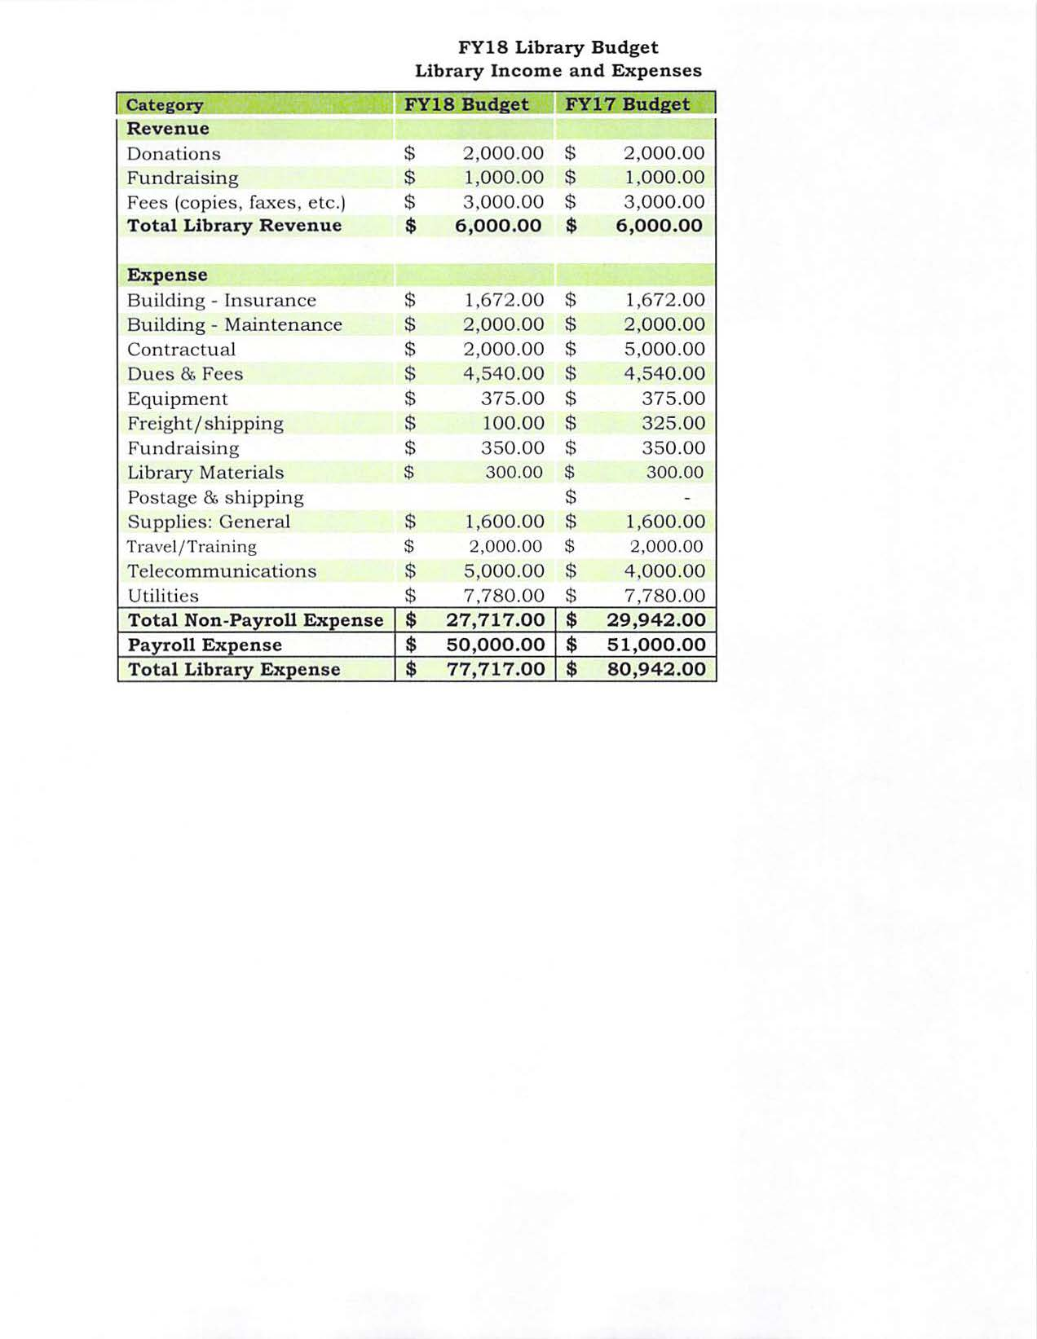

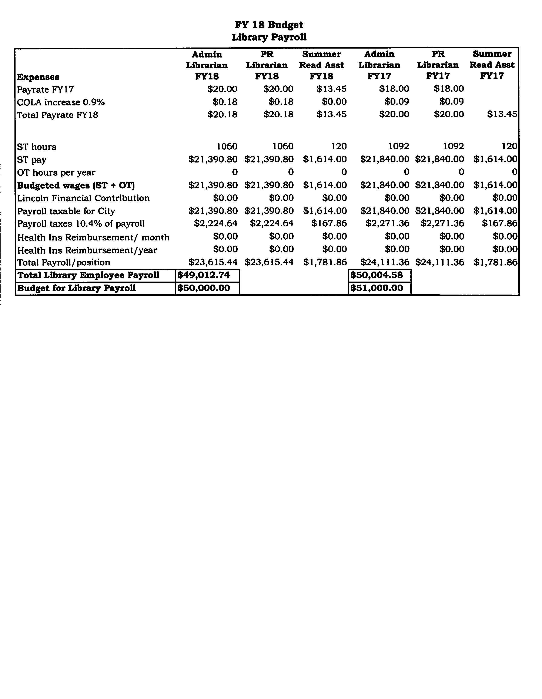

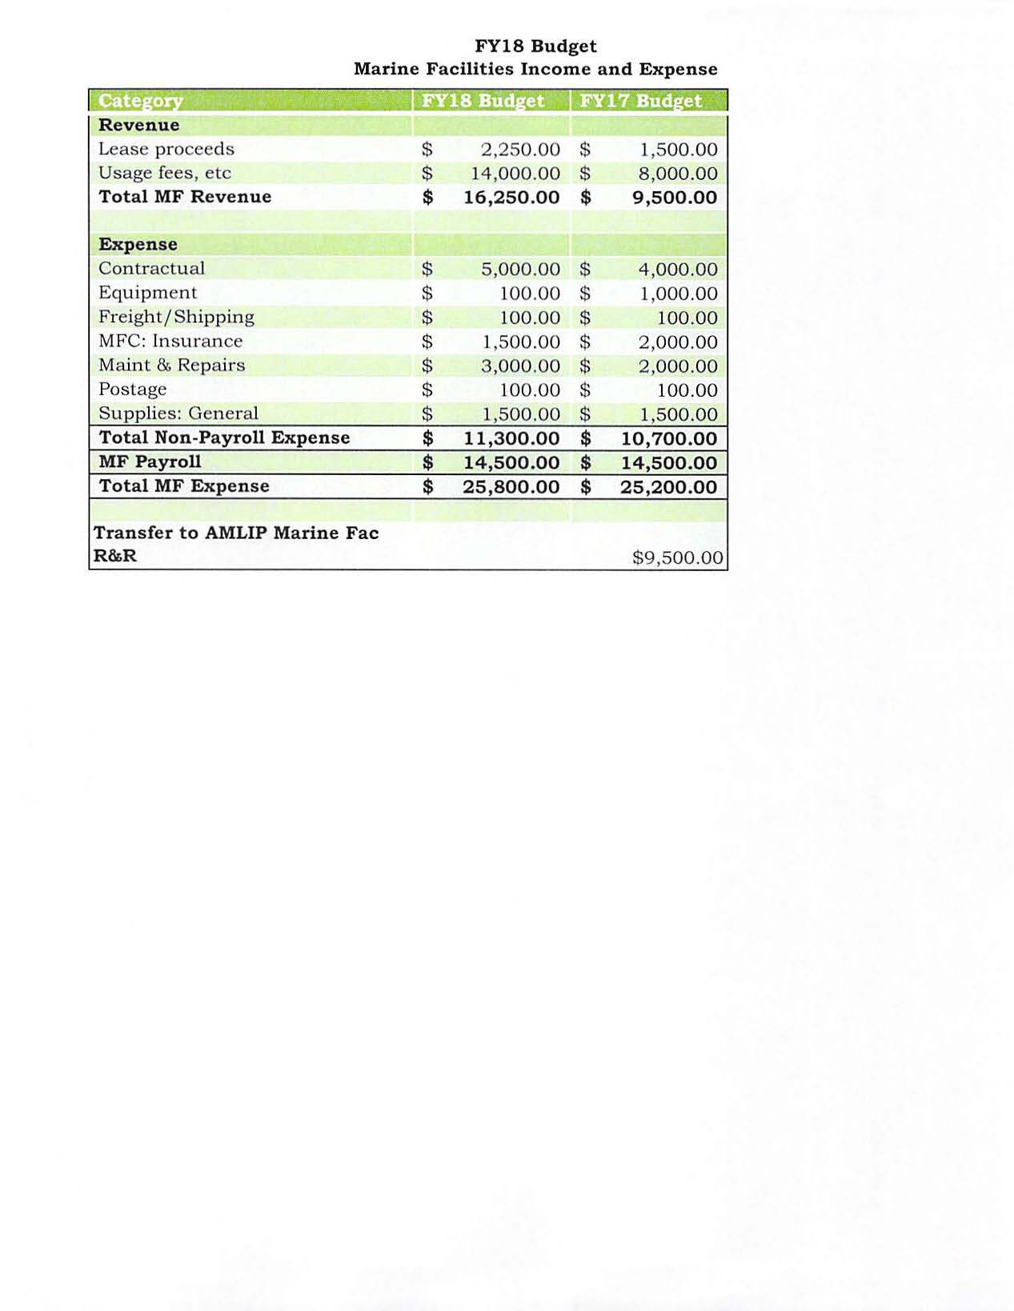

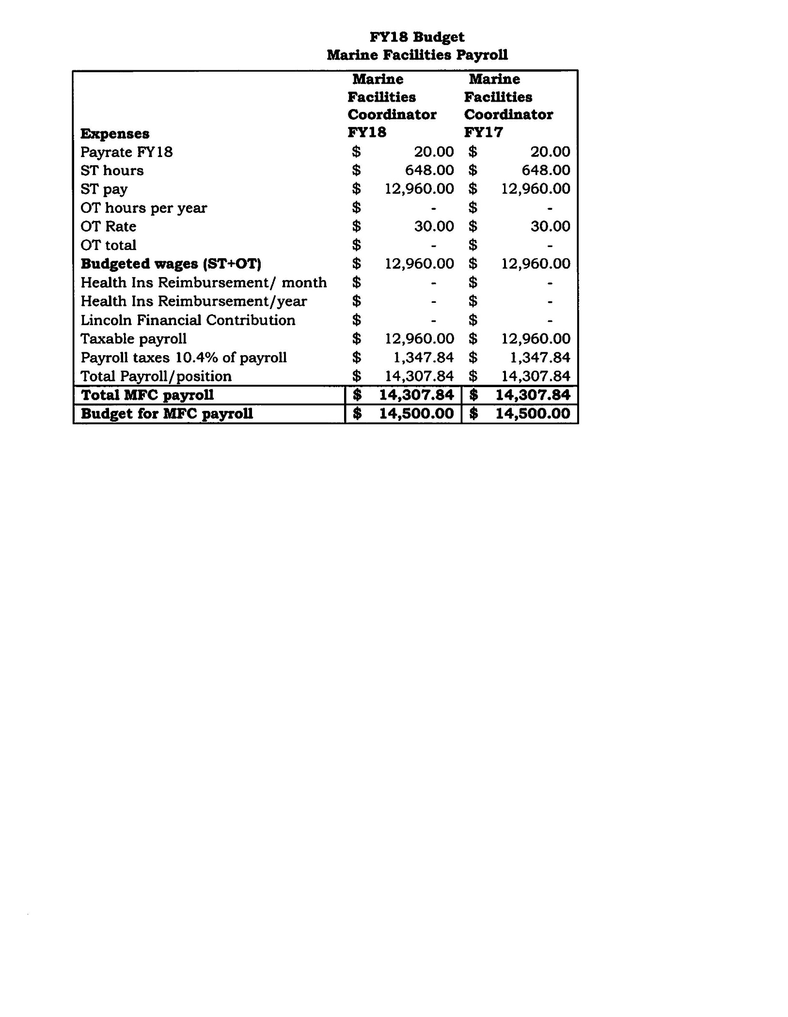

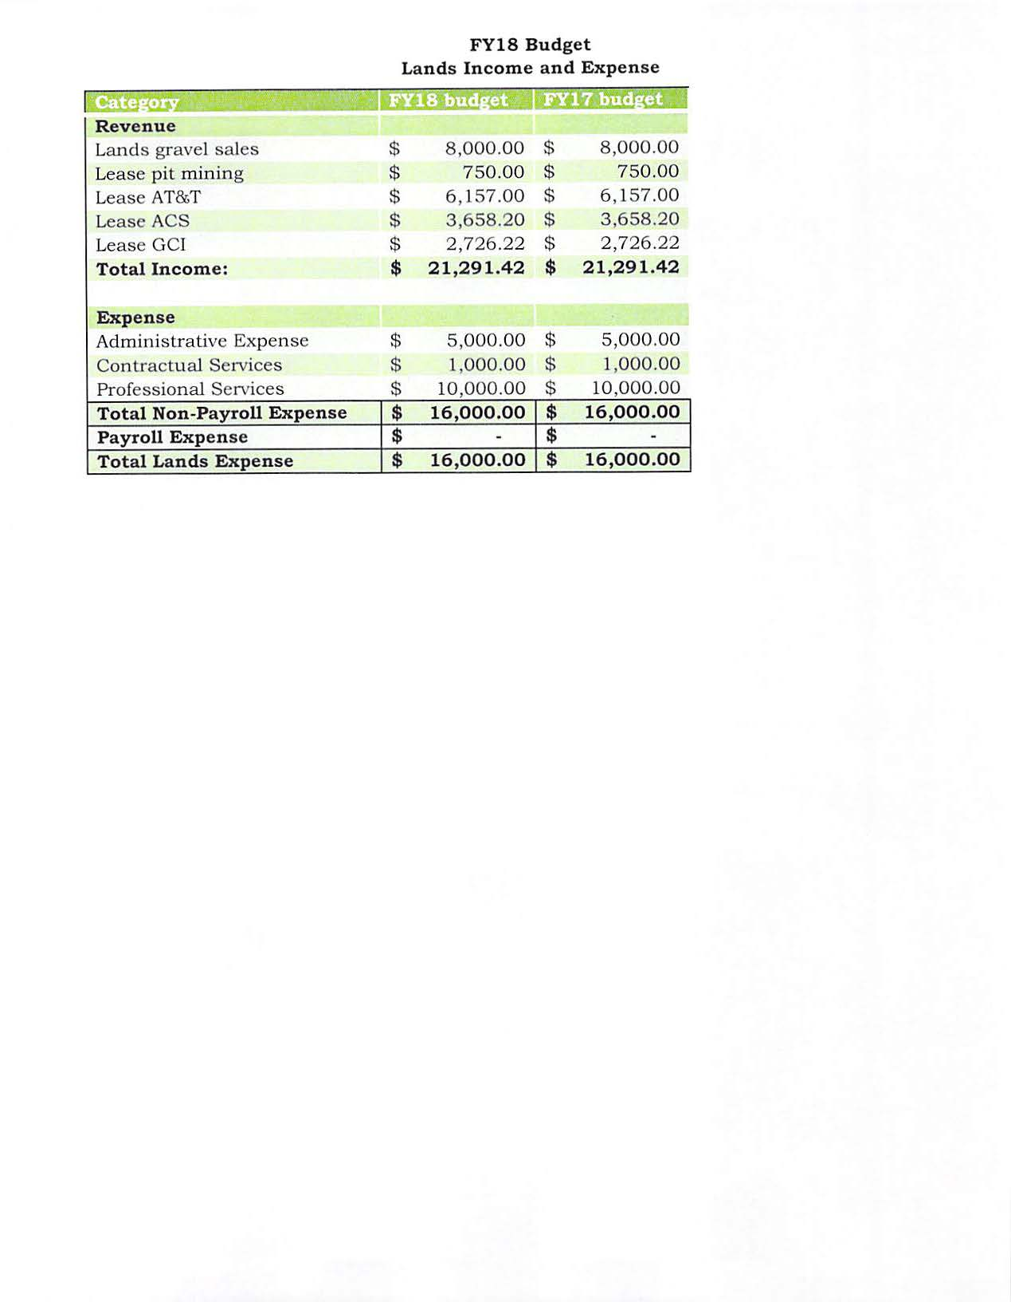

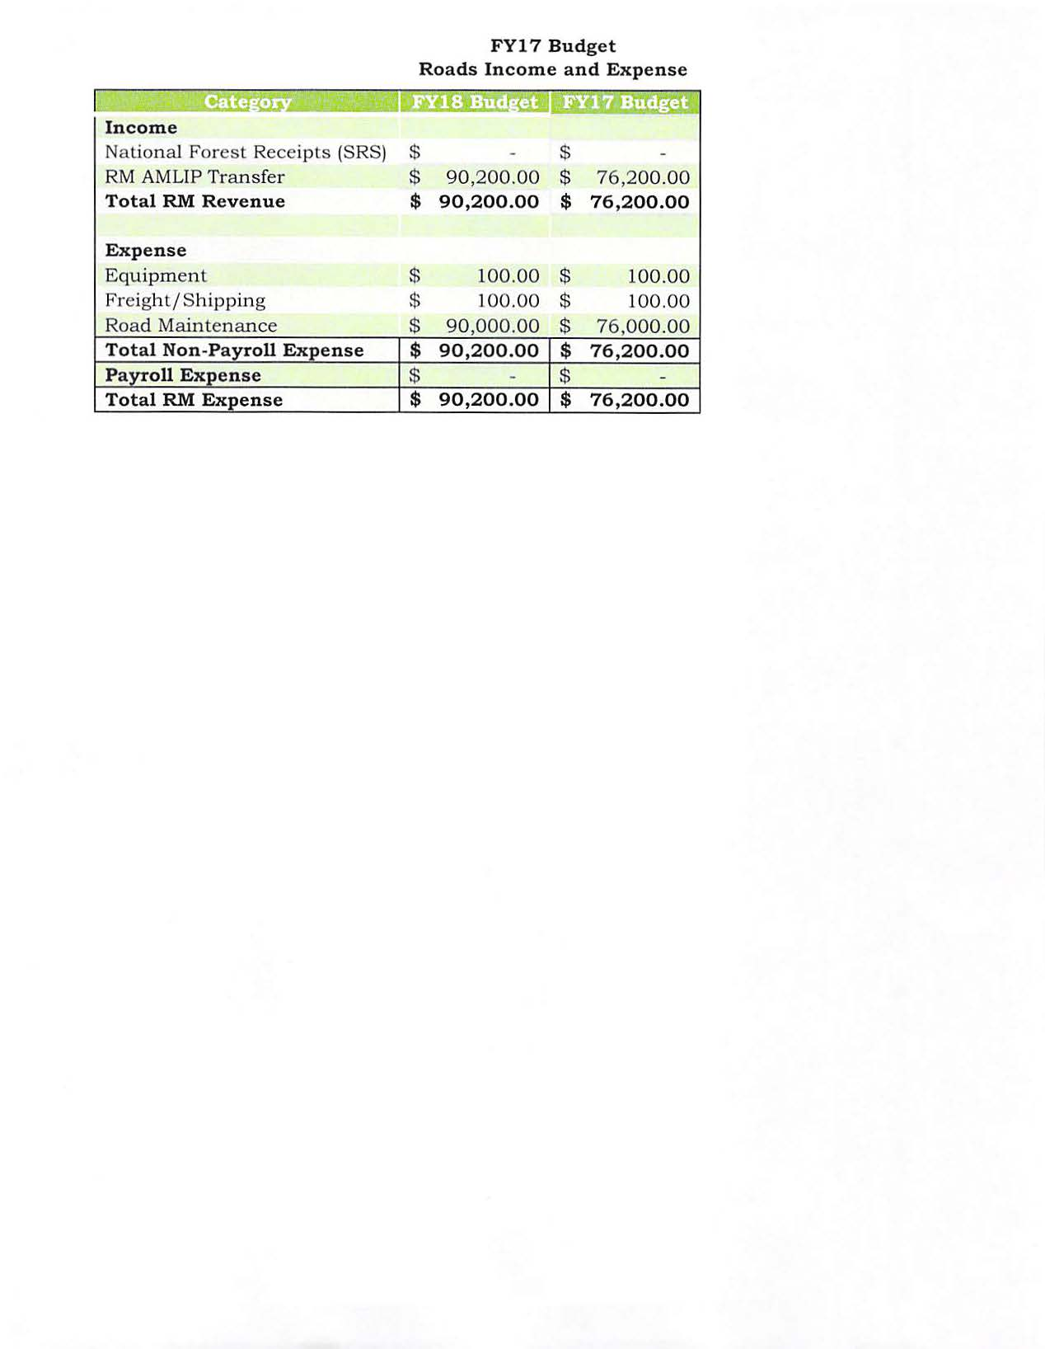

Item No. 11 Staff Reports

Item No. 12 City Council Reports

**Item No. 13 City Council Questions and Comments**

**Item No. 14 Public Comment on Non-Agenda Items**

Item No. 15 Executive Session

**Item No. 16 Adjournment**