

P UBLIC PACKET

June 12, 2017



Gustavus CITY COUNCIL

General Meeting

June 12, 2017

7:00 pm City Hall

**AGENDA**

**1. Call to Order**

**2. Roll Call**

**3. Approval of Minutes:**

**A. General Meeting Minutes May 8, 2017**

**B. Special Meeting Minutes May 15, 2017**

**4. Mayor’s Request for Agenda Changes**

**5. Department/Committee Reports:**

**A. MFC**

**6. Public Comment on Non-Agenda Items**

7.Consent Agenda

**8. Ordinance for Public Hearing:**

**A. Adopt FY17-04NCO Providing for the Establishment and Adoption of the Budget for Fiscal Year 2018**

9. Unfinished Business

**10. New Business:**

**A. Award RFQ FY17-03DRC Compost Yard Improvement**

**B. Award RFQ FY18-01RM Road Maintenance Grading**

11. Staff Reports

12. City Council Reports

**13. City Council Questions and Comments**

**14. Public Comment on Non-Agenda Items**

15. Executive Session

**16. Adjournment**

**Gustavus City Council:**

**Mayor (Seat E):**

**Tim Sunday**

**tim.sunday@gustavus-ak.gov**

**Term Expires 2018**

**Vice-Mayor (Seat F):**

**Connie Edwards**

[**connie.edwards@gustavus-ak.gov**](mailto:connie.edwards@gustavus-ak.gov)

**Term Expires 2018**

**Vacancy Posted (Seat A):**

**One Year Term Expires 2017**

**Council Member (Seat B):**

**Jake Ohlson**

**jake.ohlson@gustavus-ak.gov**

**Term Expires 2019**

**Council Member (Seat C):**

**Jon Howell**

[**jon.howell@gustavus-ak.gov**](mailto:jon.howell@gustavus-ak.gov)

**Term Expires 2017**

**Council Member (Seat D):**

**Mike Taylor**

[**mike.taylor@gustavus-ak.gov**](mailto:mike.taylor@gustavus-ak.gov)

**Term Expires 2017**

**Council Member (Seat G):**

**Barb Miranda**

**barb.miranda@gustavus-ak.gov**

**Term Expires 2017**

**Gustavus City Hall:**

**City Clerk/Treasurer**

**City Administrator:**

**Lori Ewing**

**lori.ewing@gustavus-ak.gov**

**Administrative Assistant:**

**Tanya Wagner**

**tanya.wagner@gustavus-ak.gov**

**Item No. 1 Call to Order**

**Item No. 2 Roll Call**

**Item No. 3 Approval of Minutes:**

**A. General Meeting Minutes May 8, 2017**

**GUSTAVUS CITY COUNCIL**

**GENERAL MEETING MINUTES**

**May 8TH, 2017**

**1.** **CALL TO ORDER:**

A General Meeting of the Gustavus City Council is called to order on May 8th, 2017, at 7:00pm by Mayor Sunday. There are five (5) members of the public in attendance at Gustavus City Hall.

**2**. **ROLL CALL:**

Comprising a quorum of the City Council the following are present:

Mayor Sunday

Vice Mayor Edwards

Council Member Taylor

Council Member Howell *via teleconference*

Council Member Ohlson

Council Member Miranda

The following members are not present: None

**3. APPROVAL OF MINUTES:**

**A. General Meeting Minutes April 10th, 2017**

MOTION: Vice Mayor Edwards moves to approve the General Meeting Minutes from April 10th, 2017, as presented.

SECONDED BY: Council Member Miranda

PUBLIC COMMENT: None

ROLL CALL VOTE ON MOTION:

**YES:** Sunday, Edwards, Taylor, Howell, Ohlson, Miranda

NO:

RECUSED:

MOTION **PASSES**/FAILS **6**/0

**4.** **MAYOR'S REQUEST FOR AGENDA CHANGES: None**

**5. COMMITTEE REPORTS:**

**A. GVA – written report submitted by K. Tippery, no one available for questions**

**B. DRC – written reported submitted and oral overview/questions answered by P. Berry**

**6. PUBLIC COMMENT ON NON-AGENDA ITEMS:**

A. E. Ohlson – GCEP funds/assistance for administration workload

7. CONSENT AGENDA

8. ORDINANCE FOR PUBLIC HEARING

9. UNFINISHED BUSINESS

**10. NEW BUSINESS:**

**A. Adopt Resolution CY17-05 Ensuring Continued Administration of Road Maintenance Activities**

MOTION: Council Member Miranda moves to adopt CY17-05 Ensuring Continued Administration of Road Maintenance Activities.

SECONDED BY: Council Member Taylor

PUBLIC COMMENT: None

ROLL CALL VOTE ON MOTION:

**YES:** Sunday, Edwards, Taylor, Howell, Ohlson, Miranda

NO:

RECUSED:

MOTION **PASSES**/FAILS **6**/0

**B. Adopt Resolution CY17-06 Amending the DRC Fee Schedule and Material Limitations Policy**

MOTION: Vice Mayor Edwards moves to adopt Resolution CY17-06 Amending the DRC Fee Schedule and Material Limitations Policy.

SECONDED BY: Council Member Ohlson

PUBLIC COMMENT:

A. P. Berry – notes that it has been 2 years since last increase

ROLL CALL VOTE ON MOTION:

**YES:** Sunday, Edwards, Taylor, Howell, Ohlson, Miranda

NO:

RECUSED:

MOTION **PASSES**/FAILS **6**/0

**C. Adopt Resolution CY17-07 Opposing H.R. 232**

MOTION: Council Member Taylor moves to adopt Resolution CY17-07 opposing H.R. 232

SECONDED BY: Vice Mayor Edwards

PUBLIC COMMENT: None

ROLL CALL VOTE ON MOTION:

**YES:** Sunday, Edwards, Taylor, Howell, Ohlson, Miranda

NO:

RECUSED:

MOTION **PASSES**/FAILS **6**/0

**D. Approve posting Road Maintenance RFQ FY18-01 RM**

MOTION: Council Member Taylor moves to approve posting RFQ FY18-01RM for Road Maintenance

SECONDED BY: Vice Mayor Edwards

PUBLIC COMMENT: None

ROLL CALL VOTE ON MOTION:

**YES:** Sunday, Edwards, Taylor, Howell, Ohlson, Miranda

NO:

RECUSED:

MOTION **PASSES**/FAILS **6**/0

**E. Approve posting Compost Yard Improvement Project RFQ FY17-03DRC**

MOTION: Council Member Ohlson moves to approve posting RFQ FY17-03DRC for the Compost Yard Improvement project

SECONDED BY: Council Member Howell

PUBLIC COMMENT:

A. P. Berry – thanks Council

ROLL CALL VOTE ON MOTION:

**YES:** Sunday, Edwards, Taylor, Howell, Ohlson, Miranda

NO:

RECUSED:

MOTION **PASSES**/FAILS **6**/0

**F. Approve GVFD Scoping Document for Replacing Engine 34**

MOTION: Vice Mayor Edwards moves to approve the GVFD scoping document for replacing Engine 34

SECONDED BY: Council Member Ohlson

PUBLIC COMMENT:

A. T. Miller – thanks Council, still gathering additional info

ROLL CALL VOTE ON MOTION:

**YES:** Sunday, Edwards, Taylor, Howell, Ohlson, Miranda

NO:

RECUSED:

MOTION **PASSES**/FAILS **6**/0

**G. Publish FY17-03NCO Providing for the Amendment of the City Held Accounts in Fiscal Year 2017**

MOTION: Council Member Ohlson moves to publish FY17-03NCO Providing for the Amendment of the City-held Accounts in Fiscal Year 2017.

SECONDED BY: Council Member Taylor

PUBLIC COMMENT: None

ROLL CALL VOTE ON MOTION:

**YES:** Sunday, Edwards, Taylor, Howell, Ohlson, Miranda

NO:

RECUSED:

MOTION **PASSES**/FAILS **6**/0

**H. Publish FY17-04NCO Providing for the Establishment and Adoption of the Budget for Fiscal Year 2018**

MOTION: Council Member Miranda moves to publish FY17-04NCO Providing for the Establishment and Adoption of the Budget for Fiscal Year 2018.

SECONDED BY: Council Member Howell

PUBLIC COMMENT:

A. P. Berry – thanks Council for DRC support

ROLL CALL VOTE ON MOTION:

**YES:** Sunday, Edwards, Taylor, Howell, Ohlson, Miranda

NO:

RECUSED:

MOTION **PASSES**/FAILS **6**/0

11. STAFF REPORTS

12**.** CITY COUNCIL REPORTS

**13. CITY COUNCIL QUESTIONS AND COMMENTS:**

A. B. Miranda – liked beach clean-up; walking boundaries

B. M. Taylor – thanks Tim for leadership on clean-up

C. J. Ohlson – good day on Saturday

D. J. Howell – thank you letter for tree planting at tank farm

E. T. Sunday – reminder of May 15 meetings, progress on SRP Restroom, update on: beach restrooms, Angler’s Inn signs, patent from DNR, Falls Creek, Rate Case, Broadband Plan (M.Taylor to review), Marine Facilities Coordinator

**14. PUBLIC COMMENT ON NON-AGENDA ITEMS: None**

15. EXECUTIVE SESSION

**16. ADJOURNMENT:**

Hearing no objections, Mayor Sunday adjourns the meeting at 8:23pm.

**B. Special Meeting Minutes May 15, 2017**

**GUSTAVUS CITY COUNCIL**

**SPECIAL MEETING MINUTES**

**May 15TH, 2017**

**1.** **CALL TO ORDER:**

A Special Meeting of the Gustavus City Council is called to order on May 15th, 2017, at 6:30pm by Mayor Sunday. There is one (1) member of the public in attendance at Gustavus City Hall.

**2**. **ROLL CALL:**

Comprising a quorum of the City Council the following are present:

Mayor Sunday

Vice Mayor Edwards

Council Member Taylor

Council Member Ohlson

Council Member Miranda

The following members are not present:

Council Member Howell *excused*

3.APPROVAL OF MINUTES

**4.** **MAYOR'S REQUEST FOR AGENDA CHANGES: None**

5. COMMITTEE REPORTS

**6. PUBLIC COMMENT ON NON-AGENDA ITEMS: None**

7. CONSENT AGENDA

**8. ORDINANCE FOR PUBLIC HEARING:**

**A. Adopt FY17-03NCO Providing for the Amendment of the City Held Accounts in Fiscal Year 2017**

MOTION: Vice Mayor Edwards moves to adopt FY17-03NCO providing for the Amendment of the City held Accounts in Fiscal Year 2017.

SECONDED BY: Council Member Taylor

PUBLIC COMMENT:

A. T. Imboden – cost of fire truck

ROLL CALL VOTE ON MOTION:

**YES:** Sunday, Edwards, Taylor, Ohlson, Miranda

NO:

RECUSED:

MOTION **PASSES**/FAILS **5**/0

9. UNFINISHED BUSINESS

10. NEW BUSINESS

11. STAFF REPORTS

12**.** CITY COUNCIL REPORTS

**13. CITY COUNCIL QUESTIONS AND COMMENTS: None**

**14. PUBLIC COMMENT ON NON-AGENDA ITEMS: None**

15. EXECUTIVE SESSION

**16. ADJOURNMENT:**

Hearing no objections, Mayor Sunday adjourns the meeting at 6:35pm.

**Item No. 4 Mayor's Request for Agenda Changes**

Item No. 5. Department/Committee Reports

**Item No. 6 Public Comment on Non-Agenda Items**

Item No. 7 Consent Agenda

**Item No. 8. Ordinance for Public Hearing:**

**A. Adopt FY17-04NCO Providing for the Establishment and Adoption of the Budget for Fiscal Year 2018**

**CITY OF GUSTAVUS, ALASKA**

**ORDINANCE FY17-03NCO**

**AN ORDINANCE FOR THE CITY OF GUSTAVUS PROVIDING FOR THE ESTABLISHMENT AND ADOPTION OF THE BUDGET FOR FISCAL YEAR 2018**

**BE IT ENACTED BY THE CITY OF GUSTAVUS AS FOLLOWS:**

**Section 1.** Classification. This is a **Non-Code Ordinance.**

**Section 2.** General Provisions. The attached document is the authorized budget of revenues and expenditures for the period July 1 through June 30 and is made a matter of public record.

**Section 3.** Effective Date. This ordinance becomes effective upon its adoption by the City Council.

**DATE OF PUBLICATION:** *May 08, 2017*

**DATE OF PUBLIC HEARING:** *June 12, 2017*

**PASSED** and **APPROVED** by the Gustavus City Council this ___ day of _________, 2017.

______________________________________

Tim Sunday, Mayor

__________________________________

Attest: Lori Ewing, CMC

City Clerk/Treasurer

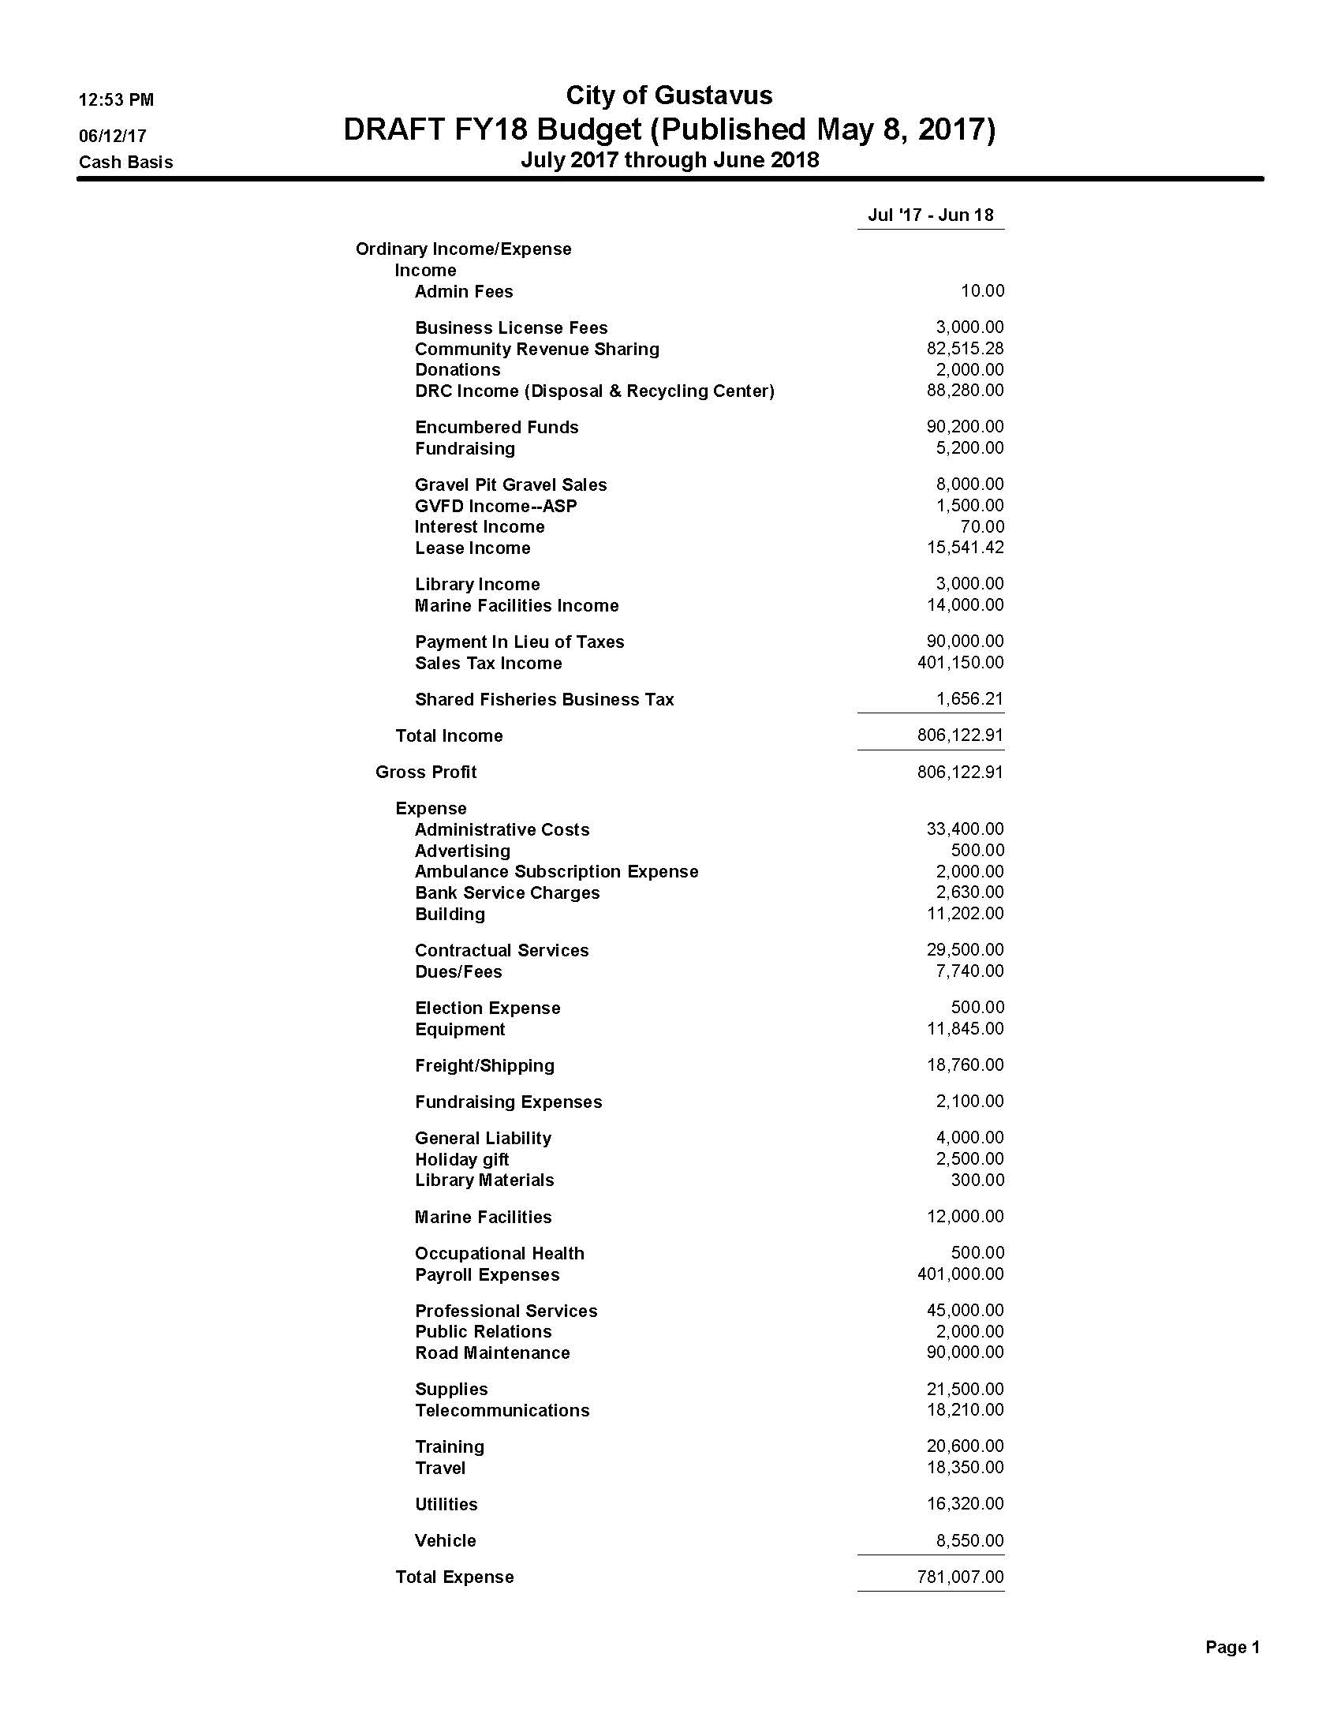

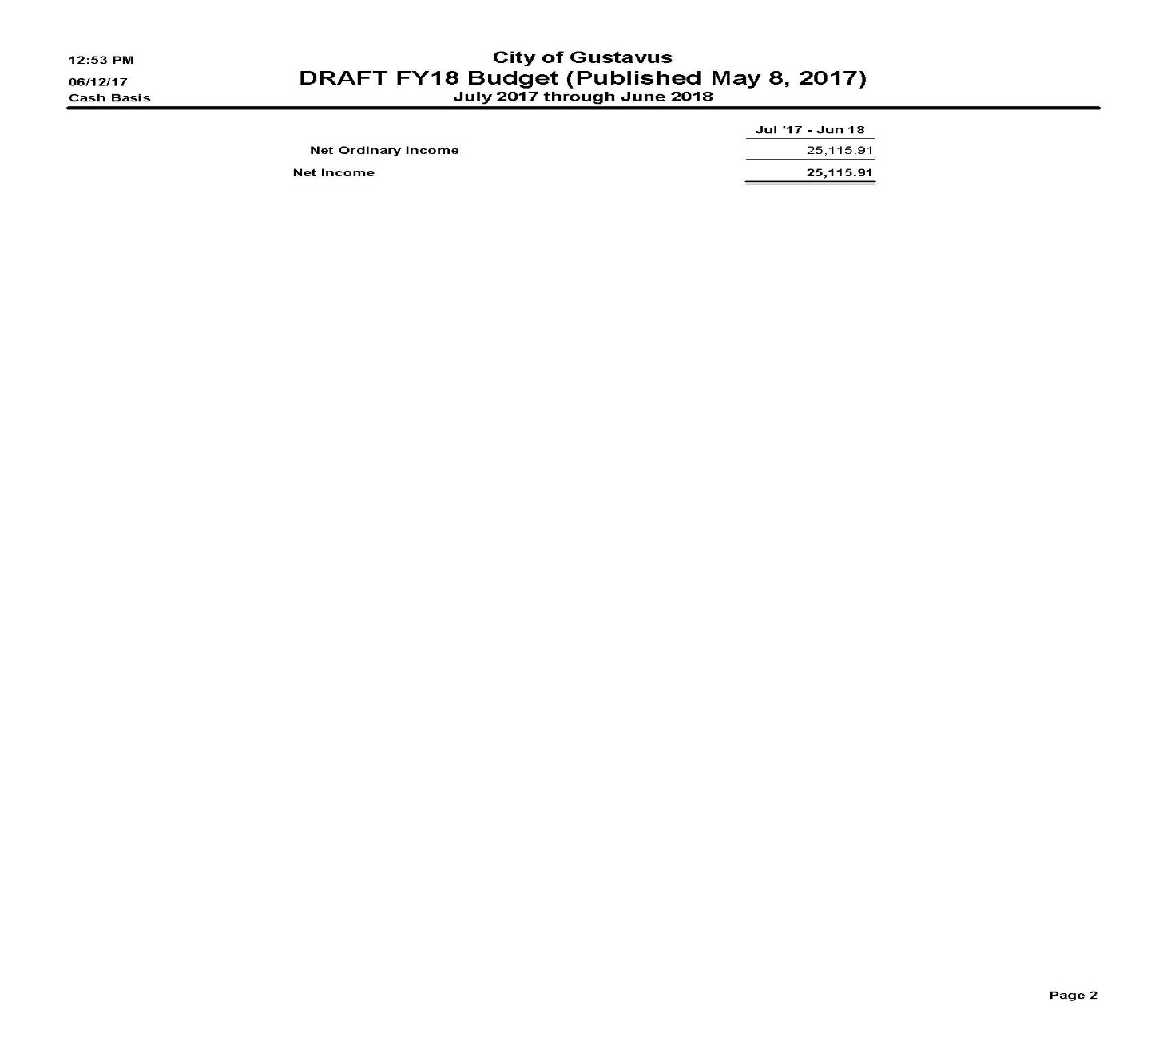

Item No. 9. Unfinished Business

**Item No. 10. New Business:**

A. Award RFQ17-03DRC Compost Yard Improvement

B. Award RFQ18-01RM Road Maintenance Grading

Item No. 11 Staff Reports

Item No. 12 City Council Reports

**Item No. 13 City Council Questions and Comments**

**Item No. 14 Public Comment on Non-Agenda Items**

Item No. 15 Executive Session

**Item No. 16 Adjournment**