

PUBLIC PACKET

September 19, 2016



Gustavus CITY COUNCIL

General Meeting

September 19, 2016

7:00 pm City Hall

**AGENDA**

**1. Call to Order**

**2. Roll Call**

**3. Approval of Minutes:**

**A. General Meeting Minutes August 8, 2016**

**4. Mayor’s Request for Agenda Changes**

**5. Department/Committee Reports:**

**A. Marine Facilities**

**6. Public Comment on Non-Agenda Items**

**7. Consent Agenda:**

**A. Approve Scoping Document-Preprocessing Storage**

**and Driveway Improvements**

**B. Publish FY17-06 Title 9 (Euthanasia Ordinance)**

**C. Ratification of Road Committee Member**

**8. Ordinance for Public Hearing:**

**A. Adopt FY17-02NCO CP17-03-SRP Waterless Restroom**

**B. Adopt FY17-04 Title 4.04.070 Amendment**

**(Budget Amendments)**

**C. Adopt FY17-05 Title 4.16.050 Amendment**

**(Fish Box Tax Clarification)**

9. Unfinished Business

**10. New Business:**

**A. Adopt Resolution CY16-12 Updating the City Benefits**

**Policy and Procedure**

**B. Approval of RFQ FY17-RM01 Snowplowing Service**

11. Staff Reports

**12. City Council Reports:**

**A. Mayor’s Report**

**13. City Council Questions and Comments**

**14. Public Comments on Non-Agenda Items**

15. Executive Session

**16. Adjournment**

**Gustavus City Council:**

**Mayor (Seat D):**

**Mike Taylor**

**mike.taylor@gustavus-ak.gov**

[**mayor@gustavus-ak.gov**](mailto:mayor@gustavus-ak.gov)

**Term Expires 2017**

**Vice Mayor (Seat E):**

**Tim Sunday**

**tim.sunday@gustavus-ak.gov**

**Term Expires 2018**

**Council Member (Seat A):**

**Lori Trummer**

**lori.trummer@gustavus-ak.gov**

**Term Expires 2016**

**Council Member (Seat B):**

**Jeff Irwin**

[**jeff.irwin@gustavus-ak.gov**](mailto:jeff.irwin@gustavus-ak.gov)

**Term Expires 2016**

**Council Member (Seat C):**

**Jon Howell**

**jon.howell@gustavus-ak.gov**

**Term Expires 2017**

**Council Member (Seat F):**

**Connie Edwards**

**connie.edwards@gustavus-ak.gov**

**Term Expires 2018**

**Council Member (Seat G):**

**Greg Streveler**

**greg.streveler@gustavus-ak.gov**

**Term Expires 2018**

**Gustavus City Hall:**

**City Clerk/Treasurer:**

**Lori Ewing**

**lori.ewing@gustavus-ak.gov**

**Administrative Assistant:**

**Tanya Wagner**

**tanya.wagner@gustaus-ak.gov**

**Item No. 1 Call to Order**

**Item No. 2 Roll Call**

**Item No. 3 Approval of Minutes**

**A. Minutes of August 8, 2016 General Meeting**

**GUSTAVUS CITY COUNCIL**

**GENERAL MEETING MINUTES**

**AUGUST 8TH, 2016**

**1.** **CALL TO ORDER:**

A General Meeting of the Gustavus City Council is called to order on August 8th, 2016, at 7:00pm by Mayor Taylor. There are eight (8) members of the public in attendance at Gustavus City Hall.

**2**. **ROLL CALL:**

Comprising a quorum of the City Council the following are present:

Mayor Taylor

Vice Mayor Sunday

Council Member Trummer

Council Member Irwin

Council Member Streveler

Council Member Howell

Council Member Edwards

**3. APPROVAL OF MINUTES:**

**A. General Meeting Minutes July 11th, 2016**

MOTION: Council Member Streveler moves to approve the General Meeting Minutes from July 11th, 2016, as presented.

SECONDED BY: Council Member Irwin

PUBLIC COMMENT: None

ROLL CALL VOTE ON MOTION

**YES:** Taylor, Sunday, Trummer, Irwin, Streveler, Edwards, Howell

NO:

RECUSED:

MOTION **PASSES**/FAILS **7**/0

**4.** **MAYOR'S REQUEST FOR AGENDA CHANGES: None**

**5. COMMITTEE REPORTS:**

**A. GVA – no report given/submitted**

**B. DRC – oral/written report by P. Berry**

**6. PUBLIC COMMENT ON NON-AGENDA ITEMS:**

**A. J. Ohlson/T. Vandenberg – Tribal House Ceremonies information**

**7. CONSENT AGENDA:**

**A. Approve Scoping Document – SRP Waterless Restroom**

**B. ~~Approve Scoping Document – Fire Hall Improvements~~ *(Move to New Business 10F requested by T. Miller)***

**C. ~~Approve Scoping Document – Roads Gravel Projects~~ *(Move to New Business 10G requested by Council Member Trummer)***

**D. Publish FY17-02NCO CP17-03-SRP**

**E. ~~Publish FY17-03NCO CP17-04 Roads~~ (*Move to New Business 10H requested by Council Member Trummer)***

**F. Publish FY17-04 Title 4.04.070 Amendment (Budget Amendments)**

**G. Publish FY17-05 Title 4.16.050 Definitions (Fish Box Tax Clarification)**

MOTION: Council Member Howell moves to adopt the amended Consent Agenda by Unanimous Consent

SECOND: Council Member Edwards

*AMENDED CONSENT AGENDA ADOPTED BY UNANIMOUS CONSENT*

**8. ORDINANCE FOR PUBLIC HEARING:**

**A.** **Adopt FY17-01 Providing for the Amendment of the City Held Accounts for FY17**

MOTION: Council Member Edwards moves to adopt FY17-01NCO Providing for the Amendment of the City Held Accounts for FY17.

SECONDED BY: Council Member Streveler

PUBLIC COMMENT: None

ROLL CALL VOTE ON MOTION

**YES:** Taylor, Sunday, Trummer, Irwin, Streveler, Edwards, Howell

NO:

RECUSED:

MOTION **PASSES**/FAILS **7**/0

9. UNFINISHED BUSINESS

**10. NEW BUSINESS:**

**A. Adopt Resolution CY16-10 to Update Resolution CY16-07 on the Broadband Plan**

MOTION: Council Member Edwards moves to adopt Resolution CY16-10 an Update to CY16-07 Approving a Broadband Planning Contract with Byte Networking for FY17

SECONDED BY: Council Member Irwin

PUBLIC COMMENT: None

ROLL CALL VOTE ON MOTION

**YES:** Taylor, Sunday, Trummer, Irwin, Streveler, Edwards, Howell

NO:

RECUSED:

MOTION **PASSES**/FAILS **7**/0

**B. Approve Purchase Order Request(s) for Road Maintenance Funds**

MOTION: Council Member Trummer moves to approve Purchase Orders awarded to Glacier Bay Construction for $15,000 for general Road Maintenance.

SECONDED BY: Council Member Streveler

PUBLIC COMMENT:

A. S. Mattson – blanket PO? Authorizations?

ROLL CALL VOTE ON MOTION

**YES:** Taylor, Sunday, Trummer, Irwin, Streveler, Edwards, Howell

NO:

RECUSED:

MOTION **PASSES**/FAILS **7**/0

**C. Adopt Resolution CY16-11 Solid Waste Management Plan Extension**

MOTION: Council Member Streveler moves to adopt Resolution CY16-11 Recognizing the Solid Waste Management Planning Accomplished to date by the DRC staff, and Endorsing Continuance of Planning in FY2017-2018.

SECONDED BY: Council Member Howell

PUBLIC COMMENT:

A. P. Berry

ROLL CALL VOTE ON MOTION

**YES:** Taylor, Sunday, Trummer, Irwin, Streveler, Edwards, Howell

NO:

RECUSED:

MOTION **PASSES**/FAILS **7**/0

*Mayor requests an AT EASE from 8:23pm to 8:28pm*

**D. Approve APT Rate Case contract with Blasco**

MOTION TO AMEND: Council Member Trummer moves to amend the motion by adding “NTE $7,500.00” after “behalf.”

SECONDED BY: Vice Mayor Sunday

MOTION: Council Member Howell moves to approve the APT Rate Case contract with Hoffman & Blasco, LLC per their letter of June 29, 2016, for signature by the Mayor on the City’s behalf NTE $7,500.00.

SECONDED BY: Council Member Irwin

PUBLIC COMMENT: None

ROLL CALL VOTE ON MOTION

**YES:** Taylor, Sunday, Trummer, Irwin, Streveler, Edwards, Howell

NO:

RECUSED:

MOTION **PASSES**/FAILS **7**/0

**E. Ratification of Road Committee Appointees**

MOTION: Council Member Trummer moves to ratify Tom Berner and Dan Pratschner as members of the Roads Committee.

SECONDED BY: Council Member Edwards

PUBLIC COMMENT: None

ROLL CALL VOTE ON MOTION

**YES:** Taylor, Sunday, Trummer, Irwin, Streveler, Edwards, Howell

NO:

RECUSED:

MOTION **PASSES**/FAILS **7**/0

**G. Approve Scoping Document – Fire Hall Improvements**

MOTION: Council Member Trummer moves to postpone indefinitely the approval of the Scoping Document – Fire Hall Improvements

SECONDED BY: Council Member Irwin

PUBLIC COMMENT: None

ROLL CALL VOTE ON MOTION

**YES:** Taylor, Sunday, Trummer, Irwin, Streveler, Edwards, Howell

NO:

RECUSED:

MOTION **PASSES**/FAILS **7**/0

**G. Approve Scoping Document – Roads Gravel Projects**

MOTION: Council Member Streveler moves to approve the Scoping Document – Roads Gravel Projects.

SECONDED BY: Council Member Irwin

PUBLIC COMMENT:

A. S. Mattson – willing to answer questions

MOTION: Council Member Trummer moves to postpone indefinitely the approval of the Scoping Document – Road Gravel Projects.

SECONDED BY: Council Member Sunday

PUBLIC COMMENT: None

ROLL CALL VOTE ON MOTION

**YES:** Sunday, Trummer, Streveler, Edwards, Howell

NO: Taylor, Irwin

RECUSED:

MOTION **PASSES**/FAILS **5**/2

**H. Publish FY17-03NCO Roads Gravel Projects**

MOTION: Council Member Trummer moves to postpone indefinitely FY17-03NCO Roads Gravel Projects.

SECONDED BY: Council Member Howell

PUBLIC COMMENT: None

ROLL CALL VOTE ON MOTION

**YES:** Taylor, Sunday, Trummer, Irwin, Streveler, Edwards, Howell

NO:

RECUSED:

MOTION **PASSES**/FAILS **7**/0

11. STAFF REPORTS

**12. CITY COUNCIL REPORTS:**

**A. Mayor’s Report – oral/written report by M. Taylor**

**13. CITY COUNCIL QUESTIONS AND COMMENTS:**

**A. T. Sunday – dock project/breakwater float update, State $2 per capita tourism dollars vs Gustavus $20 per capita if GVA receives $10,000; SRP update on land transfer – probably November at the earliest; City Hall closed to public/Council on Fridays; Community survey – questions about GCC or GVA?**

**B. L. Trummer – sea lion issue; City Hall closure on Friday – would like agreement by all Council, including Mayor, that City Hall is closed on Fridays, perhaps in the form of a Resolution**

**14. PUBLIC COMMENT ON NON-AGENDA ITEMS: None**

15. EXECUTIVE SESSION

**16. ADJOURNMENT:**

Hearing no objections, Mayor Taylor adjourns the meeting at 9:27pm.

**Item No. 4 Mayor's Request for Agenda Changes**

This is the opportunity for the Mayor to request any changes or revisions to the Agenda**. NO CHANGES INVOLVING THE CITY FINANCES ARE TO BE MADE.** If there are any changes since the first publication of the Agenda, those changes should be announced and approved.

**Item No. 5 Department/Committee Reports:**

1. **Marine Facilities**

**Item No. 6 Public Comment on Non-Agenda Items**

**Item No. 7 Consent Agenda:**

**A. Approve Scoping Document-Preprocessing Storage and Driveway Improvements**

**B. Publish FY17-06 Title 9 (Euthanasia Ordinance)**

**C. Ratification of Road Committee Member**

**A. Approve Scoping Document-Preprocessing Storage and Driveway Improvements**

**CITY OF GUSTAVUS**

**PROJECT SCOPING and DEVELOPMENT FORM**

**DISPOSAL & RECYCLING CENTER**

**PRE-PROCESSING STORAGE & SITE IMPROVEMENT PROJECT**

SUB-PROJECT Driveway improvements $10,000

SUB-PROJECT Pre-processing storage area $26,400

SUB-PROJECT Storage bins & pallet jack $18,000

SUB-PROJECT Tree Planting & Misc. Earthwork $3,300

1. **Part 1. Project Identification**

Name of project: **Pre-Processing Storage and Site Improvement Project**

Disposal & Recycling Center (DRC) Staff Contact: Paul Berry S.C.

Email: dumpmaster@gustavus-ak.gov Phone: 907-697-2118

**Part 2. Project** **scope**:

1. What is the project?

Improving public safety and improving operator safety and efficiency by addressing a major pre-processing storage need:

* + Creation of a visually screened, fenced, 8,250 sq. ft. (50' x 165') area between the existing landfill fence and Boat Harbor Rd. Visual screening fence would continue from storage area to existing 20' brown storage van.
  + Collapsible bulk containers - purchase of fifty (50) 48” by 45” by

34” bins for the pre-processing storage of recyclables (plastics, scrap metal, tin, cans, aluminum cans etc.).

Improving public safety by addressing the problem in the DRC's undersized driveway:

* + Removal of earthen berms located beside the DRC access driveway allowing for a circular traffic flow to and from the DRC's main building

Additional visual improvements:

* + The planting of approximately 10 trees between State Dock Road and the DRC

1. The replacement of what remains of the existing wooden fence with an earthen berm. Why is the project needed?

Three important goals for the DRC are addressed with this project:

* 1. Public safety

◦ Separating the public and DRC Operator work areas. The Operator should not have to pass through public work areas to store or retrieve materials. Situations where the Operator has to drive the skid-steer loader though the public work to retrieve or store bins of recyclables should be avoided.

◦ Improving visibility for drivers approaching or leaving the DRC and a wider access road allowing for better passage of two-way traffic.

* 1. Operator efficiency – it is the most efficient to store and retrieve pre-processing materials as close as possible to where they are going to be processed which for the DRC is primarily the main building.
  2. Improving visual screening so that residents and visitors will see vegetated berms, well-constructed visual screening fences and trees rather than sheds and pre-processing storage materials i.e. white goods, and storage bins.

1. Where did the idea for this project originate?

Proposed by the DRC Manager/ Operator Paul Berry.

1. Is this project part of a larger plan?

Informally the project is part of a plan to make the DRC a sustainable long-term use facility.

1. What is your time line for project planning?

The need for consolidated pre-processing storage is immediate. Local funding is proposed for the project.

1. What is your budget for the planning process? Will you be using a consultant?

Project planning to date is being done in-house. No use of a consultant is planned or budgeted at this time.

1. What is your rough estimate of the total cost of the planning and final product?

|  |  |  |  |  |  |
| --- | --- | --- | --- | --- | --- |
| **SUB-PROJECT Pre-processing storage area** | | | **$26,400.00** | | |
| Site preparation | | | $2,600.00 | | |
| 916 yards fill (8,250 sq. ft.) | | | $13,800.00 | | |
| 275' (lineal) 8' visual screening & security fence | | | $10,000.00 | | |
| **SUB-PROJECT Storage bins & pallet jack** | | | **$18,000.00** | | |
| Fifty (50) collapsible bulk storage bins w/ lids | | | $13,400.00 | | |
| All terrain pallet jack | | | $1,200.00 | | |
| Shipping | | | $2,550.00 | | |
| Contingency ~5% | | | $850.00 | | |
| **SUB-PROJECT Tree planting & misc. earthwork** | | | **$3,300.00** | | |
| Transplanting 10 trees @ $250 each | | | $2,500.00 | | |
| 4 hours misc. earthwork | | | $800.00 | | |
| **SUB-PROJECT Driveway & Access Improvements** | | | **$10,000.00** | | |
| Mob/demob equipment | | |  | | |
| Equipment time | | |  | | |
| Hauling pit run material | | |  | | |

**Total Project cost $57,700**

**Parts 3., 4., 5., 6. Project Investigation and Development**

Parts3.- 6. refer to social, environmental, and financial impacts of various options. These questions will help you document your consideration of alternatives and your choice of the option providing the best value for the community. Your goal is to generate alternatives and to make a r3ecomendation from among them. Return to Part 3., “Summary” after applying Parts 4. - 6.

**Summary:**

1. What alternative approaches or solutions were considered? Make a business case for your top two or three options by discussing how effectively each would fulfill the project goals, and by comparing the economic, social, and environmental costs vs. benefits for each one.

**Pre-processing storage area**

Pre-processing storage is the term used to describe both the physical area and the methodology used to hold recyclable materials (scrap metal, aluminum cans etc.) prior to their processing. Our current material holding methods include plastic bags inside a 20' shipping container, 32 48”x45”x36” collapsible bulk storage containers or “bins” and a variety of old totes, an open skiff, a plywood box, an old stock tank and disposable, short-life “super-sacks”.

Our current pre-processing storage area is scattered throughout the facility - some bins are stored beside the main building while others bins are inside the fenced area. This presents several problems: as the fenced landfill area continues to be used for waste burial these holding areas will have to move elsewhere and having the bins stored away from the main building means the operator has to pass through public-use areas to retrieve or store bins during the day and this presents a serious safety concern.

The no action alternative would continue the practice of storing pre-processing materials wherever they fit even if the storage areas are in multiple locations and far from the main building. This is a safety concern for the Operator when working in public work areas.

What solution was chosen as the best and why is it the best?

The most logical place for pre-processing storage is to keep the materials as close as possible to the equipment used to process the material. The 50' x 165' area between the existing landfill fence and Boat Harbor Road is proposed for use because it is currently unused, lightly vegetated and very close to the building that houses the equipment used to process the materials. With a properly hardened surface the bins could be moved with a pallet jack rather than having to use the skid-steer loader for all the bin moving needs. The public would not be using the pre-processing storage area and it does not require direct access to the main road. The project would provide an attractive appearance for our facility by having visual screening and organizing recyclable materials with stacked bins. An eight-foot-high chain link and/or wooden fence is to be used for visual screening and security. At some point in the future the pre-processing storage area could be improved with an enclosure and a concrete floor.

Visual screening improvements would be: transplanting of approximately 10 spruce trees to the area between State Dock Road and the existing band of spruce and alder trees. Trees are to be donated from local landowner(s).

Additionally, the deteriorating 12-year-old wooden fence would be replaced with an earthen berm of approximately the same height. The source of the material would be existing stockpiles at the DRC.

Creating a dedicated pre-processing storage area near to the DRC building and away from public use areas helps promote operational safety at our facility. Taking no action and not addressing the needs presented in this scoping document places the City and the public at risk.

2. Identify your funding source(s).

* How will the project be funded initially, and for its operating life?
* Is there a matching fund requirement? Please provide details.

Project is proposed to be funded out of the City reserve. Operating costs would become a part of the DRC's annual operating budget and would involve snow plowing and fence maintenance.

1. **Part 4. Environmental, Social, Financial Impacts**
2. Project Impacts Checklist

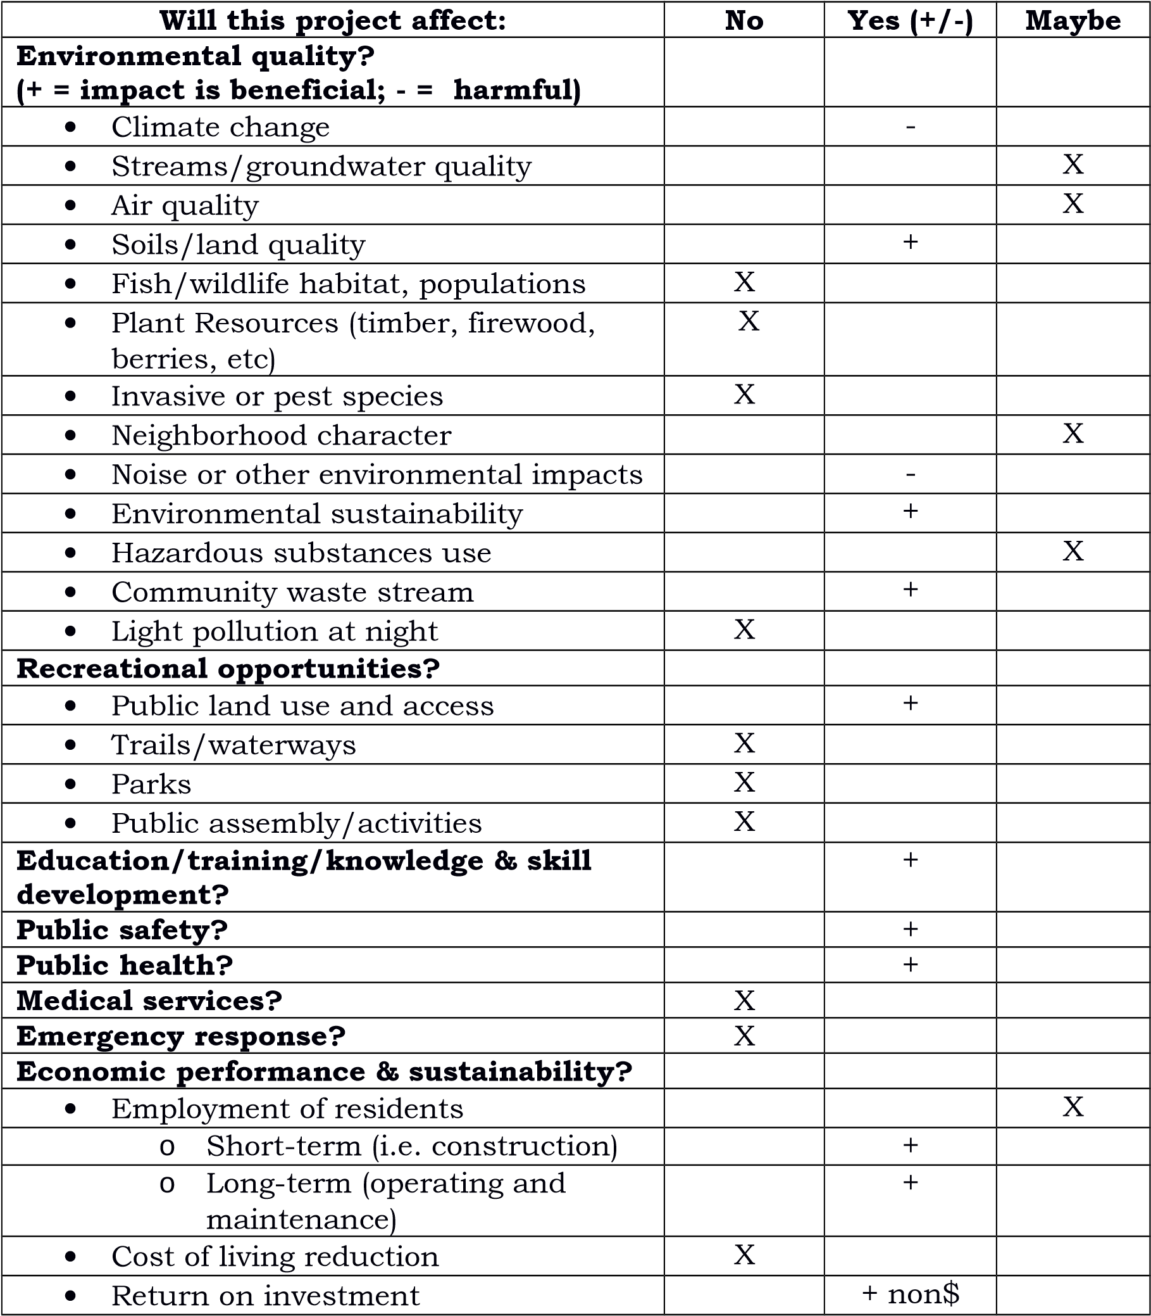

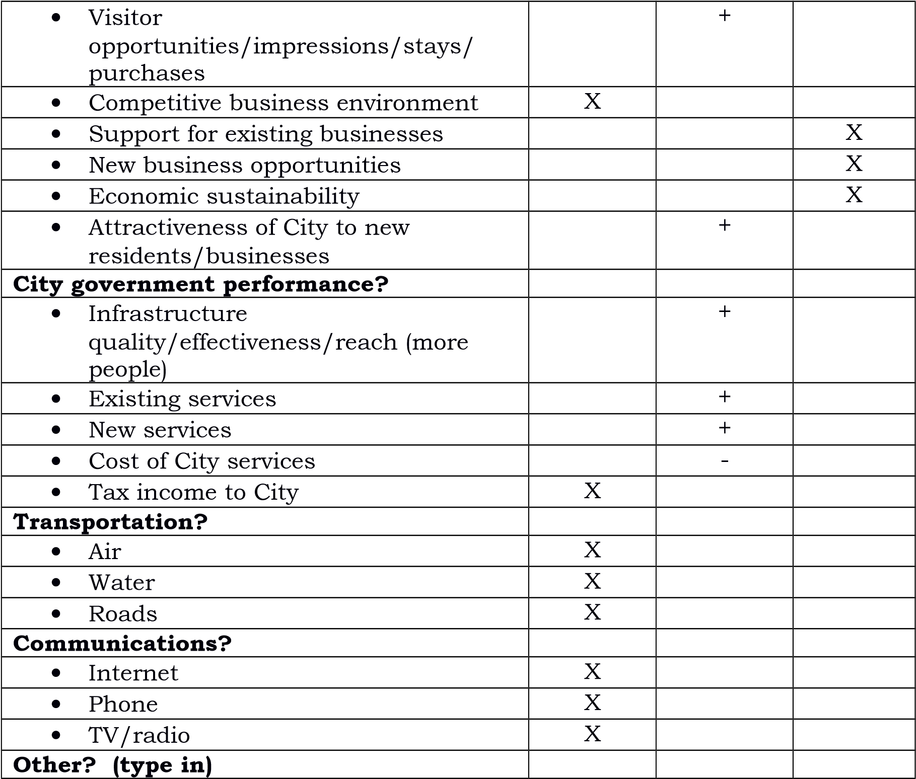

1. How does this project provide benefits or add value in multiple areas? (e.g. benefits both to the environment and business performance.) 3. Are other projects related to or dependent on this project?
   * Is this project dependent on other activities or actions?
   * If yes, describe projects, action or activities specifying phases where appropriate.

The functioning of the DRC is dependent upon the functioning of this project.

1. Will the project require additional infrastructure, activity, or staffing outside the immediate department or activity? (E.g. will the construction of a new facility require additional roads or road maintenance or more internal City staffing?)

This project does require additional infrastructure: a new operating are and fencing. Project will not require additional staffing and will result in more efficient use of Operator time.

1. What regulatory permits will be required and how will they be obtained? No permits are required for this project.
2. What are the estimated initial (e.g. construction) and continuing (operational) costs of the project?

Construction cost is estimated at $43,900. Operating costs are considered minimal and will become part of the DRC's operating budget.

1. Is an engineering design or construction estimate necessary? Yes.
2. Will operation of the project generate any revenue for the city such as sales and user fees, or new taxes? If so, how will the new revenue be collected? Any improvement to the DRC, especially in regards to recycling equipment and facility will help in recovering value from recyclable waste which will have some positive impact on the income generated from the DRC from recyclable materials sales. These sales are be used to offset operational costs.

**Part 5. Project Budget**

Administrative $0.00 Personnel $0.00

Project management $0.00 Benefits $0.00 Land, structures, ROW, $0.00 Training $0.00 easements

Design permitting and $0.00 Travel $0.00

inspection

Site work $0.00 Equipment $0.00

Construction - building $0.00 Contractual $0.00

Construction – misc. $0.00 Supplies $0.00

Equipment $0.00 Utilities $0.00

Contingencies $0.00 Insurance $0.00

Other (list) $0.00 Repair $0.00 maintenance

Other (list) $0.00 Heating $0.00

Other (list) $0.00 Other (list) $0.00

**Total direct costs $0.00**

**Total (rounded up) $0.00** Indirect costs $0.00

Updated Latest Estimate* Budget Line Items if Changed Date: _______________

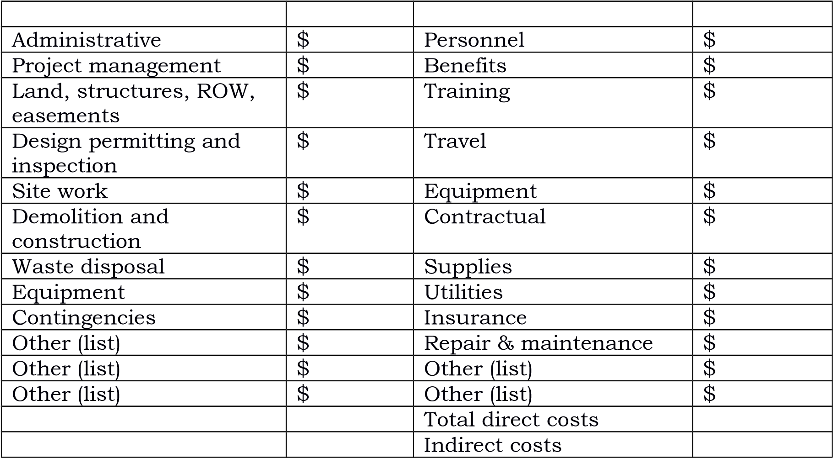

* Use this form if there are significant budget changes during development of the project.

**Part 6. Jobs and training (required by some granting agencies)**

1. What service jobs will be needed for operation and maintenance? Operation and maintenance provided by existing staff of one full-time and one part-time.
2. How many full-time, permanent jobs will this project create or retain?

Create/retain 1 full-time job in 1-3 years Create/retain 1 full-time job in 3-5 years

1. What training is necessary to prepare local residents for jobs on this project? None
2. How many local businesses will be affected by this project and how? Any business generating waste processed by the DRC will be affected by this project.
3. **Part 7. Business Plan (upon Council request)**

Upon Council request, please prepare a business plan for the operating phase of your leading option(s). Plans will differ according to the nature of the project.

**Part 8. Record of Project planning and development meetings**

**.** Please document the manner in which public input was received.

* + Public comment on agenda items at committee or Council meeting
  + Special public hearing
  + Dates and attendance for the above.
  + Written comment from the public (please attach)

1. Please use the following chart to document committee meetings, Council reports, and so on. Did the committee make recommendations or requests? Did the Council make requests of the committee?

**Meeting record**

Event Date Agenda Minutes or Outcome Number of (Meeting of Posted record Rec to attendees committee, Council, (date) Attached Council

report, (yes/no) requested

action of

Council, etc.

DRC Committee 12/14/11 12/07/11 Minutes 3

DRC Committee 12/19/11 12/07/11 Minutes 4

City Council 1/12/12 Minutes Resolution

2012-02

City Council 1/10/13 Minutes Resolution

2013-06 (not adopted)

**Part 9. Feedback to the Council**

With the understanding that this form must be adapted to a variety of projects, please provide feedback on how the form worked for your committee. Thank you for your suggestions.

1. **Publish FY17-06 Title 9 (Euthanasia Ordinance)**

**CITY OF GUSTAVUS, ALASKA**

**Ordinance FY17-06**

**AN ORDINANCE FOR THE CITY OF GUSTAVUS PROVIDING FOR THE**

**ESTABLISHMENT OF CITY ORDINANCE TITLE 9**

**BE IT ENACTED BY THE GUSTAVUS CITY COUNCIL AS FOLLOWS:**

Section 1. Classification**.** This ordinance is of general and permanent nature and shall become a part of the City of Gustavus Municipal Code.

Section 2. Severability.If any provisions of this ordinance or any application thereof to any person or circumstance is held invalid, the remainder of this ordinance and its application to other persons, or circumstances shall not be affected thereby.

Section 3. Enactment. Now therefore, it is enacted by the Gustavus City Council that **TITLE 9** be established as follows:

**Title 9 - Euthanasia**

Chapters:

**Chapter 9.01 GENENRAL PROVISIONS**

Sections:

**Section 9.01.010 - Purpose.**

The purpose of this title is:

(a) To provide for the residents of the City of Gustavus a local, compassionate, and humane means of euthanizing their animals and pets in their own home.

**Section 9.01.020 - Definitions:**

For the purpose of this ordinance, the following terms shall have the meaning given:

(a) *Domestic animals/pets:* An animal that has been trained and kept by humans as a work animal, food source or pet.

(b) *Euthanasia:* The act or practice of killing an animal that is very sick or injured in order to alleviate suffering.

(c) *Humane:* Acting in a manner that causes least harm. An action performed with tenderness, compassion, and sympathy for animals, especially for those suffering or distressed.

**Chapter 9.02 - ADMINISTRATION**

**Sections:**

**Section 9.02.010 - Interpretation:**

Unless otherwise provided, this ordinance shall be interpreted by the general rules of interpretation as provided by and for State law. Except as otherwise provided or required by context, the following specific rules of interpretation apply:

(a) Gender. Words denoting the masculine gender shall be deemed to include the feminine and neuter genders and vice-versa.

(b) Singular and plural. Words in their singular form shall include the plural and words in their plural form shall include the singular.

(c) Tenses. Words denoting the present tense shall also include the future tense.

**Section 9.02.020 – Powers and duties.**

(a) There is a need for euthanasia services for pets and domestic animals in the City of Gustavus. Currently there is no consistent and timely service available making it necessary for animal owners to call a veterinary clinic in Juneau to coordinate this service. This option is not the preferred option for many animal owners. It can be prohibitive due to the cost of flying the animal and its owner to Juneau. There is emotional distress on the part of the owner if he cannot afford the price of the ticket to accompany his animal. There can also be emotional and physical pain or distress on the part of the animal related to the flight. There can be the fear caused by the flight itself and the aggravation of pain and discomfort due to the transport to the airport and the veterinary clinic.

(b) There are residents who prefer to euthanize their animal in the comfort of their own home and familiar surroundings to the animal.

Home euthanasia may be more comfortable and compassionate for the animal.

(c) If desired, all members of the family to the animal can be present at the time of death which would likely not be possible if the animal had to be flown to Juneau.

(d) In the case of large animals, such as horses, mules, or cattle, flying the animal to Juneau is impossible.

**Section 9.02.020 – Euthanasia Committee.**

The committee for euthanasia will hereby be referred to as the “Committee”.

(a) There shall be established a Committee of at least three (3) persons dedicated to the provision and oversight of euthanasia services for the residents of the City of Gustavus.

(b) The Committee shall be made up of at least one member of the euthanasia team, one member of the community or City Council, and a veterinary supervisor of the Team.

(c) The veterinary supervisor shall be a fully licensed and accredited Physician of Veterinary Medicine in the State of Alaska.

(d) The Committee will develop and file with the City Clerk a Policy and Procedure document outlining the service and means of compliance with City ordinance.

(e) The Committee will give a formal report of Team activities and finances every six (6) months at a regularly scheduled General Meeting.

**Section 9.02.030 - Team for Euthanasia.**

The team for euthanasia will hereby be referred to as the “Team”.

(a) Each Team member will complete the required training to obtain a Euthanasia Technician Certificate. Each member will perform the required training to maintain their certificate in good standing. Copies of the certificate for all active Team members will be held by the Committee. Each Team member will be personally responsible for maintaining a current certificate and providing a current copy to the Committee.

(b) The Team will work in collaboration and under the supervision of a fully licensed and accredited Physician of Veterinary Medicine in the State of Alaska. The name, contact information and a copy of the collaborating Physician’s license, as well as the names and contact information of the Team members will be maintained by the Committee.

(c) Medications that are needed for the procedure will be obtained by a holder of an active and unhindered DEA license.

(d) Medications are to be stored in a secure location. An inventory of the medications by a person on the Committee or a Team member will be performed every three (3) months and after every procedure. Inventory will be maintained in a logbook that will be kept on the premise with the medications.

(e) If at any time the Team is unable to maintain current certification of at least one (1) of its members or if there is no supervision by a licensed and accredited Physician of Veterinary Medicine in the State of Alaska, the Team will suspend its euthanasia service until the Team becomes compliant with the requirements of this Ordinance.

**Section 9.02.04 – Severability.**

If any portion of this ordinance shall be found unconstitutional or otherwise invalid by a court of proper jurisdiction, all remaining provisions shall remain in effect and shall not be affected by the ruling on the invalid section.

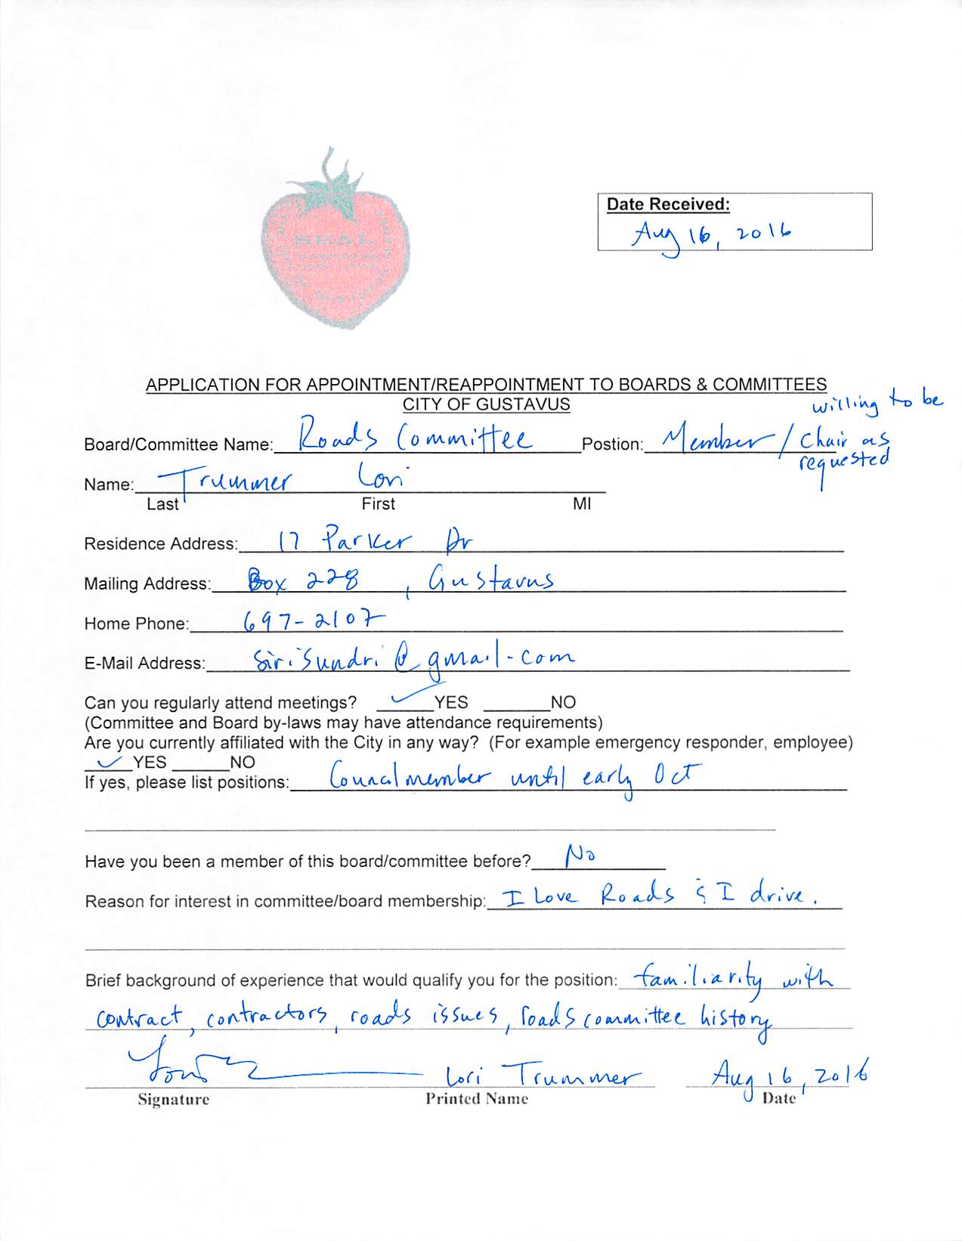

**Item No. 8. Ordinance for Public Hearing:**

**A. Adopt FY17-02NCO SRP Waterless Restroom**

**CITY OF GUSTAVUS, ALASKA**

**Ordinance FY17-02NCO**

**AN ORDINANCE FOR THE CITY OF GUSTAVUS PROVIDING FOR THE AMENDMENT OF THE CITY HELD ACCOUNTS IN FISCAL YEAR 2017**

**BE IT ENACTED BY THE GUSTAVUS CITY COUNCIL AS FOLLOWS:**

**Section 1.** Classification. This is a **Non-Code Ordinance**

**Section 2.** In Fiscal Year 2017 the following City held account balance transfers to be made for reasons stated in each transfer, with NCOs and Resolutions notated as appropriate.

**Section 3.** The budget is amended to reflect the changed estimates as follows;

**Amounts**

**Account Balance* Amended Balance Change**

*\*Approximate, this is a dynamic value.*

**ACCOUNTS**

CP17-01 -SRP Waterless Restroom$0.00 $ 34,070.72 $ 34,070.72

AMLIP - Beach $ 34,070.72 $0.00 ($ 34,070.72)

*\*Monies transferred to purchase kit; additional monies will be transferred for construction*

Total Change in Account Balances **$ 0.00**

**Section 4.** The City Held accounts are hereby amended as indicated.

**Section 5.** Effective Date. This ordinance becomes effective upon its adoption by the Gustavus City Council.

**DATE INTRODUCED:** *August 8, 2016*

**DATE OF PUBLIC HEARING:***September 19, 2016*

**PASSED** and **APPROVED** by the Gustavus City Council this _______ day of September, 2016, and effective upon its adoption.

_______________________________________

Mike Taylor, Mayor

_______________________________________

Attest: Lori Ewing, City Clerk/Treasurer

**B. Adopt FY17-04 Ordinance Title 4.04.070**

**CITY OF GUSTAVUS, ALASKA**

**Ordinance FY17-04**

**AN ORDINANCE FOR THE CITY OF GUSTAVUS PROVIDING FOR THE**

**AMENDMENT OF CITY ORDINANCE TITLE 4,**

**CHAPTER 4.04.070 AMENDMENT**

**BE IT ENACTED BY THE GUSTAVUS CITY COUNCIL AS FOLLOWS:**

Section 1. Classification**.** This ordinance is of general and permanent nature and shall become a part of the City of Gustavus Municipal Code.

Section 2. Severability.If any provisions of this ordinance or any application thereof to any person or circumstance is held invalid, the remainder of this ordinance and its application to other persons, or circumstances shall not be affected thereby.

Section 3. Enactment. Now therefore, it is enacted by the Gustavus City Council that **TITLE 4, CHAPTER 4.04.070** be amended as follows: **Bold and underlined** items are additions.

Chapter 4.04.070 Amendment

**The City Clerk/Treasurer may modify line item expenditures within an authorized appropriation to another line item in any amount which would not annually exceed ten (10) percent or $1,500, whichever is more. For amounts over ten (10) percent or $1,500 and for transfers to or from AMLIP accounts, Endowment accounts, or any other accounts,** the budget can be amended by the Council at any time after adoption provided no such amendment shall be made until after a public hearing.

Section 4. Effective Date**.** This ordinance becomes effective upon its adoption by the Gustavus City Council.

**Date Introduced:** *August 8, 2016*

**Date of Public Hearing:** *September 19, 2016*

**Passed** and **Approved** by the Gustavus City Council this _____ day of _________, 2016.

____________________________________

Mike Taylor, Mayor

____________________________________

Attest: Lori Ewing, City Clerk/Treasurer

**C. Adopt FY17-05 Ordinance Title 4.16.020 Definitions**

**CITY OF GUSTAVUS, ALASKA**

**Ordinance FY17-05**

**AN ORDINANCE FOR THE CITY OF GUSTAVUS PROVIDING FOR THE**

**AMENDMENT OF CITY ORDINANCE TITLE 4,**

**CHAPTER 4.16.020 DEFINITIONS**

**BE IT ENACTED BY THE GUSTAVUS CITY COUNCIL AS FOLLOWS:**

Section 1. Classification**.** This ordinance is of general and permanent nature and shall become a part of the City of Gustavus Municipal Code.

Section 2. Severability.If any provisions of this ordinance or any application thereof to any person or circumstance is held invalid, the remainder of this ordinance and its application to other persons, or circumstances shall not be affected thereby.

Section 3. Enactment. Now therefore, it is enacted by the Gustavus City Council that **TITLE 4, CHAPTER 4.16.020** be amended as follows: **Bold and underlined** items are additions.

Chapter 4.16.020 – Definitions

*Buyer:* Includes, without limiting the scope thereof, every consumer.

*City:* The City of Gustavus, Alaska, or the area within the territorial limits of the City of Gustavus, Alaska.

*City Council:* The Gustavus City Council or the Gustavus City Council's designees.

*Fish box:* A container of fish and/or seafood that has been caught or taken under the services of a commercial sport fishing charter service **and any self-guided charter service** conducting business in the City of Gustavus that is processed and/or packaged in the City of Gustavus.

*Fish charter:* A fish charter is any boat trip for hire during which fishing takes place. Included are all trips that take place in whole or in part within the city, or utilize city infrastructure, or begin or end in the city, regardless of the buyer's place of residence and regardless of where the majority of the charter is conducted. **This also includes “bare boat” charters and/or self-guided trips.**

*Flat-rate:* A per-unit assessment that is separate from and not including sales or service taxes.

*Include and including:* "By way of illustration only" and shall not be interpreted as a limitation except where expressly so provided.

*May:* Permissive.

*Mayor:* The city mayor or his/her authorized designee.

*Must and shall:* Each is mandatory.

*Packaged:* Contained, protected, and preserved for transport and/or storage and/or use.

*Person:* An individual natural person.

*Process:* A procedure, method, or system for altering, preparing, or refining a product.

*Retail sale:* Any sale of real or tangible personal property including barter, credit, installment and conditional sales for any purpose other than resale in the regular course of business. The delivery of goods in the city by a seller whose principal place of business is outside the city to a buyer or consumer is a retail sale made within the city if such retailer maintains any office, distribution, or sales house, warehouse or any other place of business, or solicits business or received orders through any agent, salesman, or other type of representation within the city.

*Sale for resale:* The sale of tangible personal property to a buyer whose principal business is the resale of the property whether in the same or altered form.

*Seafood processor:* For purpose of the fish box flat-rate tax, a seafood processor is a person and/or business who prepares fish/seafood for transport and/or storage and/or use by one, some or all of the following: eviscerate ("gut"), skin, cut, fillet, freeze, smoke, and/or package.

*Seller:* Every person, firm, corporation or other legal entity making retail sales to a buyer or consumer, renting property or performing services for consideration whether acting as principal or using the services of an agent or broker.

*Selling price and price:* The gross amount of a transaction between a buyer and a seller.

*Services:* All services of every manner and description that are performed or furnished for consideration whether in conjunction with the sale of goods or not, but does not include services rendered by an employee to an employer. All retail services by a seller within the city of services to be provided or performed in whole or in part within the city, or utilize city infrastructure regardless of the buyer's place of residence, or buyer's physical location upon acceptance of the offer, or exchange of consideration.

*State:* State of Alaska.

*Sticker:* A city-authorized, dated, numbered, self-adhesive label approved by the Gustavus City Council.

Section 4. Effective Date**.** This ordinance becomes effective upon its adoption by the Gustavus City Council.

**Date Introduced:** *August 8, 2016*

**Date of Public Hearing:** *September 19, 2016*

**Passed** and **Approved** by the Gustavus City Council this _____ day of _________, 2016.

____________________________________

Mike Taylor, Mayor

____________________________________

Attest: Lori Ewing, City Clerk/Treasurer

Item No. 9. Unfinished Business

**Item No. 10. New Business:**

**A. Adopt Resolution CY16-12 Health Benefits**

**CITY OF GUSTAVUS, ALASKA**

**RESOLUTION CY16-12**

**A RESOLUTION BY THE CITY OF GUSTAVUS UPDATING THE CITY BENEFITS POLICY AND PROCEDURE**

**WHEREAS,** City of Gustavus last updated its employee benefits policy and procedure effective July 1, 2015, and;

**WHEREAS,** the City of Gustavus values its employees and intends to compensate employees competitively within our region, and;

**WHEREAS,** the City of Gustavus encourages regular employees to carry health insurance and has provided a partial reimbursement program with a monthly individual cap of $655 for those regular employees with no other access to an employer’s health insurance program, and;

**WHEREAS,** health insurance rates on the Affordable Care Act marketplace for Alaska are projected to increase approximately 10% for calendar year 2017, and;

**WHEREAS,** the City of Gustavus has no employee defined contribution retirement plan, but encourages its regular employees to save for retirement through a deferred compensation program with an employer match of 2% of monthly straight time pay, and;

**WHEREAS,** many employers offer a higher employer match or other means of assisting employees in saving for retirement, and;

**NOW THEREFORE BE IT RESOLVED** that effective November 1, 2016, the City of Gustavus updates its Employee Benefits Policy and Procedure as attached to:

1) Increase the regular employee health care reimbursement cap by 10% to $720.00 per month for qualified employees, and

2) Stipulate an employer match cap of 5% of straight time monthly pay for qualified regular employees contributing to their deferred savings plan.

**PASSED** and **APPROVED** by the Gustavus City Council this ____ day of __________, 2016,

and effective upon adoption.

_______________________________________

Mike Taylor, Mayor

­­­­­­­­­­­­­­­­­­­­­­______________________________________________________________

Attest: Lori Ewing, City Clerk/Treasurer

**City of Gustavus**

**Policies and Procedures**

**Title: City of Gustavus Benefits Policy for Eligible Regular Position Employees Effective November 1, 2016**

**BACKGROUND:**

By Ordinance FY2012-13 adopted April 12, 2012, the Gustavus City Council approved a major revision to Title 3, Personnel. Revised Title 3 provides that it is the policy of the City of Gustavus to establish and amend, from time to time, by resolution, a written benefits policy, which describes various non-wage compensations that the City provides to employees in addition to wages or salaries. [CoG 3.05.01]

Consistent with the provisions of revised Title 3, the City Council adopted by Resolution 2012-17 this “City of Gustavus Benefits Policy,” which applies to all eligible Regular Position employees. This updated policy, effective November 1, 2016, replaces all previous City of Gustavus benefits and leave policies. CoG 3.04.01(b) (1)]

**I. Health Insurance Premium Reimbursement**

This benefit is provided to all Regular Position employees in proportion to hours worked each month, according to the following provisions:

**POLICY:**

The City of Gustavus will reimburse the health insurance premiums paid by qualifying employees in a gross amount of up to $720 per month. To qualify for participation in this program, the employee must be (1) a Regular Position employee who (2) submits valid documentation verifying that he or she has paid amounts toward the premium required by an individual or family insurance plan under which the employee is insured. The City will not reimburse health insurance premium expenses incurred under insurance policies that are part of another employer-sponsored or group insurance plan, nor policies that do not specifically insure the employee. The City will not reimburse health insurance premium expenses incurred by any person or entity other than the employee.

**PROCEDURE:**

(A) On a monthly basis, the City Clerk/Treasurer will make a disbursement in an amount that is the lesser of $720 or the amount actually paid by the qualifying employee in that month, to reimburse that employee's health insurance premium payments. All reimbursement amounts are subject to tax reporting and withholding and the employee will be paid a net amount.

(B) To receive reimbursement, the employee must provide proof to the City Clerk/Treasurer quarterly of (1) an active and current individual or family health insurance policy under which the employee is insured and (2) the amounts actually paid by the employee towards the premium for which the employee seeks reimbursement. The City will not make advance payments. Employees who have not actually made a health insurance premium payment but merely anticipate doing so do not qualify for this benefit.

(C) The maximum obligation of the City under this policy, per qualifying employee, is $720 per month, or the premium amount actually paid by the employee, whichever is less. Any premium amount exceeding $720/month will be the responsibility of the employee.

(D) This benefit will commence upon satisfactory completion of the probationary period.

(E) Employees receiving a benefit under this section must notify the City before the next pay period if they become ineligible for coverage under this policy. Failure to do so will result in the City recovering the amount of any improper reimbursements from the employee’s future paychecks.

**II. Deferred Compensation Program, a 457(b) Retirement Savings Plan**

The City participates in a 457(b) deferred compensation program with Lincoln Life. A 457(b) plan is a type of tax-advantaged deferred-compensation retirement plan that is available to state or local governments and their agencies. The employer provides the plan and the employee defers compensation into it on a pre-tax basis. Participation is voluntary. The participant contributes a flat amount of his/her choice each month, which is withdrawn from the monthly paycheck. The City will match the employee’s monthly contribution up to a maximum of 5% of the employee’s straight time pay for the month. Regular Position employees may contact the City Clerk/Treasurer for more information.

**III. Paid Holidays [CoG 3.05.02]**

The City of Gustavus observes the following eight holidays:

1. New Year’s Day (January 1)

2. President’s Day (third Monday in February)

3. Memorial Day (last Monday in May)

4. Independence Day (July 4)

5. Labor Day (first Monday in September)

6. Thanksgiving (fourth Thursday in November)

7. Day after Thanksgiving

8. Christmas (December 25).

* The City will grant an eight-hour day of paid holiday time to all Regular Position employees, both fulltime and part-time.

* Holiday pay will be calculated based on the employee’s straight-time pay rate as of the date of the holiday. Employees will not receive additional compensation when a recognized holiday falls on a day an employee is on Paid Time Off. Employees will not receive compensation for a holiday that occurs on a day that the employee is on an unpaid leave of absence.
* This benefit will commence upon satisfactory completion of the probationary period.
* See Gustavus Municipal Code 3.05.02 for the application of the policy to Monday through Friday and Tuesday through Saturday work weeks.

**IV. Paid Time Off (PTO)**

The City of Gustavus recognizes that employees have diverse needs for time off from work. PTO will cover all forms of personal, vacation, and sick leave. This benefit will be granted to all Regular Position employees in proportion to the hours worked each month.

Paid Time Off is a provision for time taken off from an employee's regularly scheduled work hours. PTO may not be applied to days and hours the employee is not scheduled to work. With the exception of the permitted 60-hour carry-over of unused PTO hours at the start of a new fiscal year, PTO not taken during regularly scheduled work hours will be forfeited. Unused accrued PTO is cashed out only when an employee terminates.

* An employee’s annual PTO benefit accrues in accordance with employment longevity as shown in the table below. Accrual rates for a new longevity category begin on the first day of the month of the employment anniversary.
* Annual PTO benefit accruals begin July 1 of each year and end June 30 of each year.
* A maximum of 120 hours of PTO may be carried over into the next fiscal year.
* Accrued PTO hours beyond 120 at the end of the fiscal year will be forfeited.
* For new hires, PTO will accrue retroactive to the date of hire if and when the employee satisfactorily completes the probationary period.
* An employee must receive approval from his/her supervisor for planned PTO. Approval of PTO is contingent upon the needs of the department/facility. In cases of emergency or illness, an employee must let his/her supervisor know about the absence as soon as possible.
* Upon termination an employee shall be paid the value at the time of cash-out of remaining PTO.
* PTO must be used in full before an employee may request unpaid leave.

**Longevity Categories**

PTO is accrued on an hourly basis, and is credited on the monthly pay check in proportion to the actual straight-time hours worked that month. Accruals are based on longevity, that is, the number of years employed in a Regular Position with the City of Gustavus. The following table depicts Annual PTO accrual for a fulltime Regular Position, 2,080 hours/year.

|  |  |  |
| --- | --- | --- |
| Longevity | Annual PTO Accrual,  Fulltime equivalent | Accrual Rate  PTO hours/actual  straight-time hours worked* |
| Less than two (2) years | 80 hours | 0.0413223 |
| Two (2) through five (5) years | 120 hours | 0.0632911 |
| Six (6) or greater years | 160 hours | 0.0862068 |

*“Actual number of straight-time hours worked” means the total straight- time paid hours, minus holiday hours minus annual PTO accrual hours. (Overtime hours do not count toward PTO accrual.)

**Formula**

* Accrued PTO hours on a monthly (or any) pay check = (Actual number of straight-time hours worked) (accrual rate)
* The same accrual rate works for any employee in a given Longevity Category. Accrual rate = annual PTO accrual allotment divided by (2080 - 64 holiday hours – annual PTO accrual allotment)

**V. The City of Gustavus does not offer Compensatory Time Off.**

**B. Publish RFQ FY17-RM01- Snowplowing Service**

City of Gustavus, Alaska

PO Box 1

Gustavus, Alaska 99826

Phone: 907-697-2451

Fax: 907-697-2136

Email: [treasurer@gustavus-ak.gov](mailto:treasurer@gustavus-ak.gov)

or mayor@gustavus-ak.gov



**Project: RFQ FY17-RM01**

**Snowplowing Request for Quotation**

**THIS IS NOT AN ORDER**

REQUEST FOR QUOTATION

SNOWPLOWING SERVICE WINTER 2016-2017

Important Dates:

**Issue Date: September 20, 2015**

**Bid Submittal Due: October 3, 2016 Bid Opening: October 3, 2016**

Deliver to: Gustavus City Hall Location: Gustavus City Hall

By: 1:00 pm. Time: 1:00 pm

The City of Gustavus seeks to develop a list of parties interested in providing snowplowing service on City roads and facilities during the 2016-2017 winter on an “as available basis”. Qualified parties will be called on a rotating basis as needed and issued a Purchase Order to plow specific roads or facility areas following snow storms. To qualify, parties must have a heavy plow truck or motor grader capable of plowing roads to City specifications. They must also show proof of insurance meeting City requirements before receiving a Purchase Order. Those requirements are attached to this notice. In addition, to qualify, a party must not have an overdue account with the City for any taxes or usage fees. The City will pay for plowing of roads on a per-mile basis, as ordered each time by the Road Committee by Purchase Order, with the miles of each road being determined by the official list of road lengths on the attached schedule and map.

**Procedure for selection of qualified parties for snowplowing service**

1. Contractors complete the attached quotation form and submit it to the City Clerk/Treasurer at City Hall by October 3, 2016.

2. The City will review quotations and notify parties whether they will be qualified pending submission of proof of insurance.

3. Qualifying contractors submit proof of insurance to the City Clerk/Treasurer. Insurance certificate must indicate that the City will be informed if the insurance is cancelled for any reason during the insurance period.

4. The City Clerk/Treasurer will check insurance certificates for compliance with City requirements.

5. The City Clerk/Treasurer will notify qualified parties of their entry onto a list of available contractors for snow-plowing services.

**Procedure for calling out contractors and monitoring snowplowing service**

1. The Road Maintenance Committee will monitor snow conditions and determine when roads or facility areas need to be plowed. Generally plowing will be ordered before snow depths reach 10 inches.

2. The Road Maintenance Committee will contact approved snowplowing contractors on a rotating basis to order plowing service. During particularly difficult conditions more than one qualified contractor may be offered work to plow specific areas of the City.

3. When offered snowplowing work a qualified contractor may accept or decline the work.

4. If the notified contractor declines the work for a particular opportunity, the City will offer the work to the next qualified contractor on the list. Contractors who decline work for a specific event will remain qualified for future call-outs without prejudice.

5. When a contractor accepts snowplowing work they will be issued a Purchase Order for the work detailing the specific roads and areas to be plowed. Generally, the City will expect the contractor to complete the plowing within two days of the order to plow.

6. The Road Maintenance Committee will spot check plowed roads and areas to determine whether plowing meets specifications, and determine acceptability prior to approving an invoice from the contractor.

**City of Gustavus Winter 2016-2017 Snowplowing Quotation Form**

Quoting Party, or business name: _________________________________________________

The above party proposes to offer snowplowing services to the City of Gustavus for the 2016-2017 winter according to the following schedule of rates:

**Roads on the City road map** and road list as requested by the City designee will be plowed at a rate of $_____________/mile, with mileage as indicated on the City road list.

**City facility areas** will be plowed as requested by the City designee at the following rates:

**City Hall access road and parking areas:** $______________per plowing.

**Library driveway and parking area:** $______________per plowing.

**Boat harbor area (road, ramp, 72-hour parking):** $______________per plowing.

**Fire Hall paved apron:** $______________per plowing.

**DRC entry and parking:** $______________per plowing.

**Community Chest paved apron**: $______________per plowing.

**Clinic Driveway and parking:** $______________per plowing.

Please list equipment and individual hourly rates for use in work not in bid schedule.

|  |  |
| --- | --- |
| **Equipment Item Description** | **Hourly Rate** |
|  |  |
|  |  |
|  |  |

In quoting snowplowing service to the City of Gustavus for winter 2016-2017, I have read and understand the City snowplowing specification and insurance requirements, as attached, the list of City Roads, as attached, and the corresponding City road map, as attached. I understand that call-outs will be on an as-needed basis and that I will be issued a purchase order for specific services before beginning the plowing. The City may issue a purchase order in advance but with a separate notice to proceed to be issued orally or by email from the City Road Maintenance Committee or City Clerk/Treasurer when services are to begin. I understand that I am responsible for billing the city for accepted services following completion. I also understand that I shall respectfully request any members of the public with complaints or comments to direct their comments to City Hall or a member of the Road Committee.

________________________________________ _________________________________________  
Original Signature Address

________________________________________ __________________________________________  
Name/Title (print or type) Telephone Number

**INSURANCE REQUIREMENTS**

During the term of the contract, the Contractor shall obtain and maintain in force the insurance coverage specified in this section with an insurance company rated “Excellent” or “Superior” by A. M. Best Company or as specifically approved by the City Council.

Limits: The Contractor shall obtain insurance for not less than the following limits:

* Commercial general liability: coverage written on an occurrence basis with limits of not less than $1,000,000 per occurrence;
* Comprehensive automobile liability: $1,000,000 combined single limit;
* Workers’ compensation: $100,000 each accident, $500,000 disease--policy limit, and $100,000 disease--each employee.

Automobile Liability Insurance: All autos, or all owned, non-owned, and hired automobiles must be insured when the Contractor is using them to do work under this Agreement. If the Contractor submits insurance covering only scheduled autos, then the Contractor must assure that any additional vehicles are insured before using them in the work under this contract.

Workers’ Compensation: Any employee of the Contractor must be covered by workers’ compensation insurance during the term of the Agreement. This policy must be endorsed with a waiver of subrogation in favor of the City. The Contractor is not required to provide a certificate of workers’ compensation insurance if the Contractor certifies in a manner acceptable to the City that the Contractor has no employees subject to the Act. The Contractor is not required to provide a certificate of workers’ compensation covering certain employees under the following circumstances: *Corporations* - If the executive officer claims an exemption, then the Contractor must provide a certificate of waiver for that officer from the Alaska Department of Labor; *Sole Proprietors –* The Contractor must sign a workers’ compensation release on a form provided by the City; *Partnerships* - Every partner must sign a workers’ compensation release on a form provided by the City.

Alternate Coverage: A combination of primary and excess/umbrella policies may be used to fulfill the insurance requirements of this section.

Additional Insured: During the contract term, the Contractor shall add and maintain the City as an additional insured in the Contractor’s commercial general liability policy. This policy will provide primary coverage for the City, and it will provide that the policy treats each additional insured as though the insurer had issued separate policies.

Certificate of Insurance: Prior to commencing any work under this Agreement, the Contractor will provide a certificate of insurance in a form acceptable to the City showing that the Contractor has the required insurance coverage.

Cancellation: The Contractor must assure that the City receives notice if the Contractor’s insurance is going to be canceled, not renewed, or changed. The certificate of insurance must say that the insurer will notify the City at least 30 days before the insurer cancels, refuses to renew, or materially changes the coverage.

Increased Coverage:If during the Agreement term the City requires higher limits of insurance than those listed in this section, and if the insurer increases the premium as a result of the higher limits of insurance, then the City will pay the Contractor the difference between the new and old premiums.

Subcontracting: The Contractor is responsible to the City to verify insurance on all subcontractors and furnish copies of it to the City upon request. All subcontractors must carry and show proof of the minimum limits of liability indicated above.

**END OF INSURANCE REQUIREMENTS**

|  |  |
| --- | --- |
| **ROUTE NAME** | **LENGTH (MILES)** |
| **Area 1** |  |
| Owen+Porcupine | 0.27 |
| Veneta | 0.41 |
| Trudy | 0.38 |
| Lynn | 0.14 |
| Snow | 0.18 |
| Tong - main stem (E-W to intersection) | 0.48 |
| Tong - Branch A (N-S intersection through center of subdivision) | 0.41 |
| Tong - Branch B (extension to start of Country Inn driveway) | 0.13 |
| Owen's Ditch Road | 0.50 |
| XtraTuff (off Tong Branch A) | 0.10 |
| Spruce | 0.37 |
| Bartlett | 0.31 |
| **Area 1 Total Miles** | **3.68** |
|  |  |
| **Area 2** |  |
| Good River Road | 0.86 |
| Mary's Road | 0.22 |
| Grandpa's Farm Road | 0.59 |
| Meadow Lane | 0.28 |
| Dickey Drive | 0.35 |
| **Area 2 Total Miles** | **2.30** |
|  |  |
| **Area 3** |  |
| Dolly Varden | 0.65 |
| Smelt | 0.05 |
| Greenling | 0.18 |
| Chinook | 0.35 |
| Chum | 0.16 |
| King Salmon | 0.15 |
| Sandlance | 0.14 |
| Halibut | 0.33 |
| Capelin | 0.10 |
| Humpy | 0.27 |
| Needlefish | 0.13 |
| Sockeye | 0.29 |
| Herring Lane | 0.14 |
| Coho | 0.27 |
| Steelhead | 0.25 |
| Candlefish | 0.10 |
| Willow Way (Formerly “Yurtville”) | 0.44 |
| Shooting Star | 0.10 |
| Lupine | 0.12 |
| City Hall Access | 0.10 |
| **Total Area 3 Miles** | **4.32** |
|  |  |
| **Area 4** |  |
| Wilson Road | 2.10 |
| Fara Way | 0.29 |
| White | 0.32 |
| Parker | 0.30 |
| Harry Hall/Chuck Kearns | 0.40 |
| River Bend | 0.17 |
| Chase | 0.40 |
| Jensen | 0.20 |
| Mackovjak’s Road | 0.25 |
| **Area 4 Total Miles** | **4.43** |
|  |  |
| **Area 5** |  |
| Rink Creek Road | 3.74 |
| Bouy Drive | 0.21 |
| Island View Drive | 0.28 |
| **Area 5 Total Miles** | **4.23** |
|  |  |
| **Area 6** |  |
| Boat Harbor Road | 0.21 |
| Bill's Drive | 0.25 |
| Meadowbrook Lane | 0.24 |
| Fairweather | 0.25 |
| Pleasant Avenue | 0.23 |
| Jacob | 0.27 |
| Gustav | 0.19 |
| Travis | 0.20 |
| Benjamin | 0.18 |
| Glen's Ditch Road | 0.20 |
| Same Old Road | 0.83 |
| Dungeness Way | 0.11 |
| Glen's Ditch to Nagoonberry Trail parking | 0.31 |
| End of the Trail | 0.26 |
| **Area 6 Total Miles** | **3.73** |

**Total City Road Miles = 22.69**

**SECTION 215**

**SNOW PLOWING**

**215-1.01 Description**

This work consists of plowing snow from specified City roadway surfaces and from special areas of City property such as driveways, parking areas, and the boat harbor uplands. The Road Committee shall designate one person to be responsible for ordering snow plowing. The Contractor shall be notified if another Road Committee member substitutes in that designee’s place, or if the order will come from the Mayor or the City Clerk/Treasurer, in the absence of the Mayor. All snow plowing shall commence within 12 hours from the time the Contractor is called out by the Road Committee designee unless otherwise arranged with the Road Committee.

**215-2.01 Plowing Requirements**

The roadway surface shall be cleared of snow from roadway shoulder to roadway shoulder each time it is plowed, with the exception of those designated by the Road Committee as impractical to do because of obstructions or width. Contractor shall plow snow evenly to both sides of the road such that berms along both sides are approximately equal throughout the winter—unless otherwise agreed by the Road Committee.

Roads that have not been cleared to a width of at least sixty feet (60’) may or may not be cleared after snowfall has reached a depth of eighty inches (80”). Snowfall amounts will be determined for Gustavus by NOAA, or the National Weather Service. Snow berms shall be winged back at road intersection radii to a maximum height of 30 inches measured from the roadway centerline. This shall apply to City roads and intersections only.

Gravel shall not be plowed off the road surface. It is acceptable to leave up to two inches of snow or hard pack on the road surface over the gravel.

The Contractor shall be responsible for all damages caused to the roadway surface and damages to any facilities, public or private, located in or along the roadway. Traffic surfaces of special areas such as City driveways and parking lots and the boat harbor uplands shall be cleared of snow and the snow shall be piled at locations designated by the Road Committee designee.

**215-3.01 Method of Measurement**

Snowplowing of City roads will be measured by miles of road plowed. City road lengths have been determined by the Road Committee and are provided to the Contractor at the time of bidding. The Road Committee shall specify to the Contractor which roads are to be plowed. The Road Committee designee will call out the Contractor to plow snow on specified roads before 10 inches of fresh snow has accumulated. Fresh snow is defined as snow no more than three (3) days old.

Special areas such as City driveways, parking areas, and the boat harbor will each have unit prices per complete plowing as determined in the bid.

**215-4.01 Basis of Payment**

Snow plowing will be paid for at the contract bid unit price per mile for specified roads, and per contract bid unit price for plowing for specified special areas, completed and accepted by the Road Committee. The Road Committee designee may order plowing of snow under special conditions, or in locations not addressed in the bid documents, and make payment according to the contractor’s hourly billing rate for the equipment used.

**END OF SECTION**

Item No. 11 Staff Reports

**Item No. 12 City Council Reports:**

**A. Mayor’s Report**

**Item No. 13 City Council Questions and Comments**

**Item No. 14 Public Comment on Non-Agenda Items**

Item No. 15 Executive Session

**Item No. 16 Adjournment**