From: Gustavus Visitors Association Gateway to Glacier Bay <info@gustavusak.com>
Sent: Sunday, January 7, 2024 7:34 PM
To: Kimber Owen <seawolfoffice@gmail.com>
Cc: Shelley Owens <shelley.owens@gustavus-ak.gov>
Subject: Fwd: Gustavus Lands

Leah Okin
President
Gustavus Visitors Association
PO Box 167
Gustavus, AK 99826
www.gustavusak.com
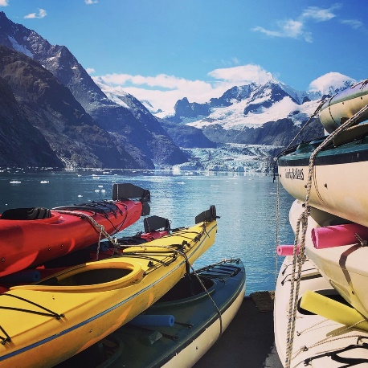

---------- Forwarded message ---------
From: Glacier Bay Construction <gbciak@gmail.com>
Date: Sat, Jan 6, 2024 at 8:15 AM
Subject: Fwd: Gustavus Lands
To: <info@gustavusak.com>

Begin forwarded message:

From: Glacier Bay Construction <gbciak@gmail.com>
Date: January 6, 2024 at 8:06:53 AM AKST
To: alaska@tnc.org
Subject: Gustavus Lands
﻿
﻿
Ivy Spohnholz, State Director, TNC Alaska
The Nature Conservancy Alaska Program
715 L St., Suite 100 Anchorage, AK 99501

Dear Ivy:

I was never on the side of the state of Alaska removing public lands into private ownership to start with. Be that as it may, I do not support yet another transfer of these lands to HIA. Their organization is well intended, however they have not demonstrated any ability to function in the community. I’ll point you to the situation regarding the historic Gustavus Inn property, which hasn’t functioned since their purchase. The community needs lodging and having the place empty is a real problem. They have made no effort to inform the community of their intentions or efforts to get it into operation. They certainly don’t need to mismanage more real property here.

Furthermore, I would like to take this opportunity to ask that the Nagoon Berry Trail have some maintenance done on it. Our company donated a significant amount of work on the parking area, so I feel we room to complain. The trail itself is an orphan at present with vegetation clearing and surface maintenance being virtually nonexistent over the years. The city had to pay for signage that points visitors to the area, which seems extremely odd. Really not impressed with TNC’s stewardship thus far.

Appreciate your attention in this matter.

Regards

Justin Marchbanks, 28 year resident
Glacier Bay Construction
Gustavus AK.

