From: Susan Brook
To: Liesl Barker
Subject: Re: NEWS 911 UPDATE
Date: Thursday, January 25, 2024 11:37:33
Attachments: image001.png

Thank you to everyone who worked to make this happen.

From: Liesl Barker <liesl.barker@gustavus-ak.gov> Sent: Thursday, January 25, 2024 11:10:51 AM Subject: NEWS 911 UPDATE

You can now call 911 from your cell phone when in Gustavus and you will be directly connected to Gustavus Dispatch. Thank you to our EMS Coordinator, Fire Chief, Mayor, City Administrator and Doc for working with several entities to make this happen. This has been a long ongoing effort during which we experienced some difficulties. Thank you to all of you for your patience.
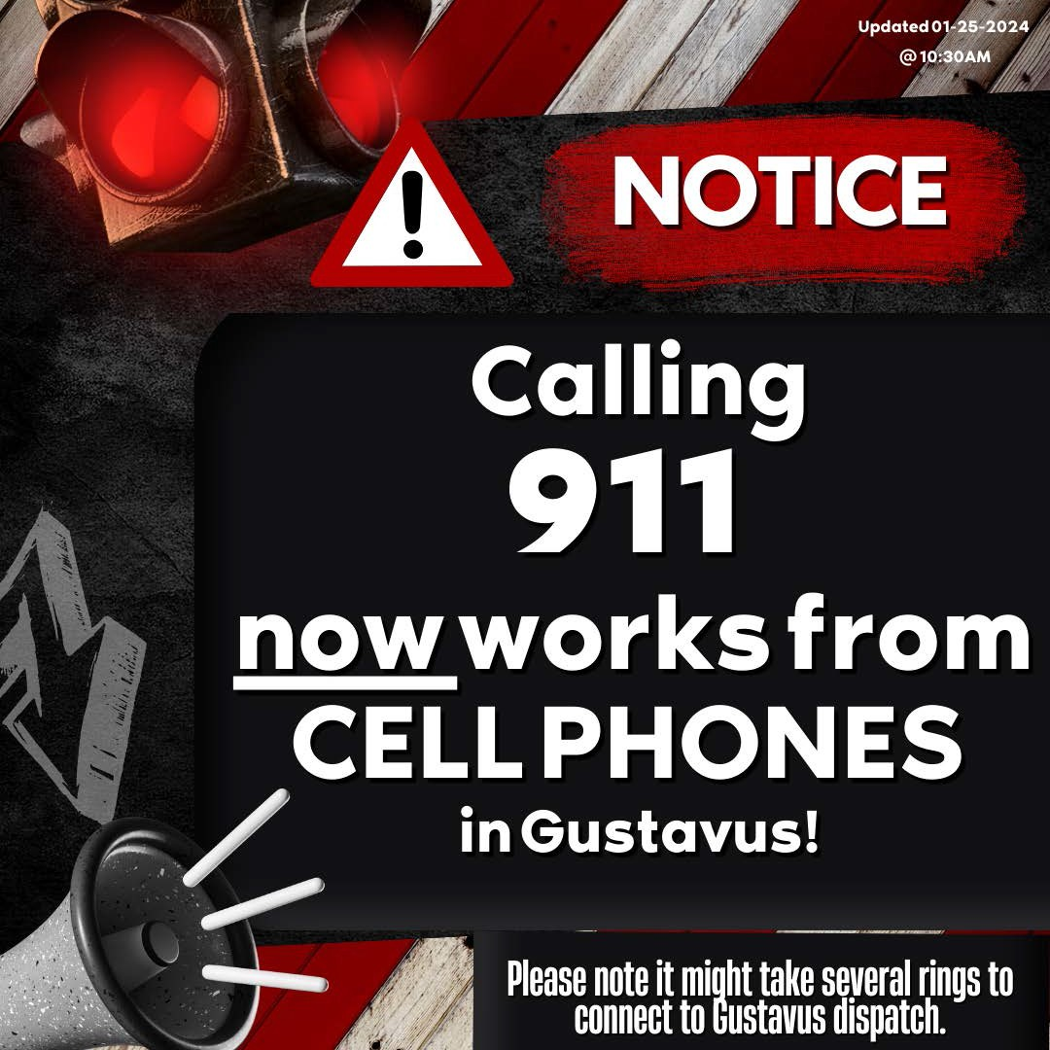
Respectfully, Liesl Barker
City Clerk, City of Gustavus, Alaska
P.O. Box 1, Gustavus, AK 99826
Office: (907) 697-2451. Fax: (907) 697-2136
clerk@gustavus-ak.gov https://www.gustavus-ak.gov/

PUBLIC RECORDS LAW DISCLOSURE: This e-mail and responses to this email are subject to provisions of the Alaska Statutes and may be made available to the public upon request.

