From: Liesl Barker
To: Liesl Barker
Subject: Fwd: FW: Xunaa Borough and available lands
Date: Thursday, January 25, 2024 12:45:32
Attachments: image.png image.png
Xunaa_state lands.pdf Xunaa_watershed.pdf

---------- Forwarded message ---------
From: Kathy Leary <kathy.leary@gustavus-ak.gov> Date: Thu, Jan 25, 2024 at 10:17
Subject: FW: Xunaa Borough and available lands To: Liesl Barker <lieslbarker@gmail.com>

Probably should have copied you too!

Kathy Leary

City Administrator City of Gustavus (907) 697-2451
administrator@gustavus-ak.gov

https://gustavus-ak.gov/

PUBLIC RECORDS LAW DISCLOSURE: This e-mail and responses to this email are subject to provisions of the Alaska Statutes and may be made available to the public upon request.

From: Kathy Leary
Sent: Thursday, January 25, 2024 10:15 AM
To: jedediah.smith@alaska.gov
Cc: Mayor <mayor@gustavus-ak.gov>; Whitney Rapp <whitneyrapp@gmail.com>
Subject: FW: Xunaa Borough and available lands

Good morning, Jed.

Whitney graciously looked at the maps you provided since there are questions by her and many others regarding how much state land is within the proposed borough for the 10 percent land entitlement. The concern is mostly about whether Hoonah will be able to select alternate lands should there not be sufficient acreage within the proposed boundaries. Another concern is about land that might be selected so close to Gustavus’s boundary and potential for development.

Additionally - we are still hoping to see a map of the boundaries in which we receive PILT or other acreage/area/boundary dependent funding. We’d like to compare that to the proposed boundary to assess financial impacts.

Kathy Leary

City Administrator City of Gustavus (907) 697-2451
administrator@gustavus-ak.gov

https://gustavus-ak.gov/

PUBLIC RECORDS LAW DISCLOSURE: This e-mail and responses to this email are subject to provisions of the Alaska Statutes and may be made available to the public upon request.

From: Whitney Rapp <whitneyrapp@gmail.com>
Sent: Wednesday, January 24, 2024 10:27 PM
To: Kathy Leary <kathy.leary@gustavus-ak.gov>; Shelley Owens <shelley.owens@gustavus- ak.gov>
Subject: Xunaa Borough and available lands

OK, my Starlink is currently in a tunnel of melted snow, so I have limited connectivity. My attendance tomorrow will be challenged, unless I physically appear. Meeting being recorded?

1 parcel of "selected" state lands... it's currently federal but probably DNR selected it... 427.59 acres
58 parcels of state lands totaling 4981.41 acres. Most are pretty small. Of these, 2 parcels totaling 503.23 have "limited rights" in the GIS layer. I didn't follow up, but I would suspect harder to acquire. So that's 4478.18 acres. The state layer I downloaded is not super helpful as to what department holds or otherwise. I do see "MH" which clues me into mental health. It would take more effort than I have right now to parse out the holdings.

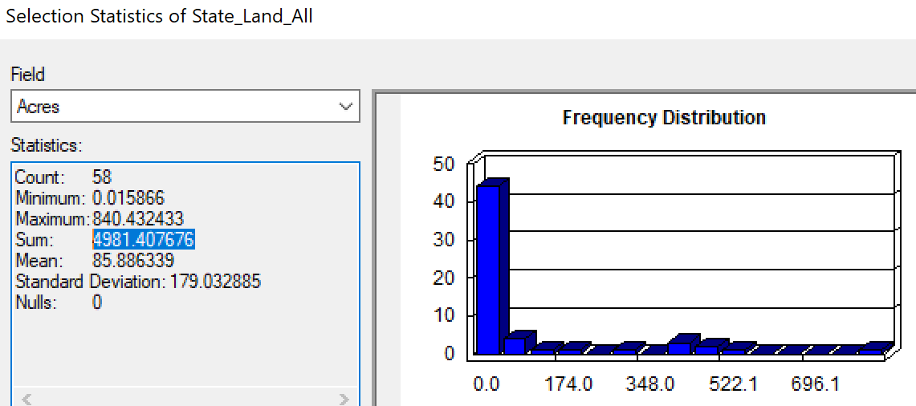

Within Gustavus, there are 41 parcels in the State data layer. The state still has the TNC parcels in their layer, which is suspect, but not a rabbit hole I'm going to investigate tonight. These 41 parcels total 15130.45 acres (yes way more than in Xunaa boundary)

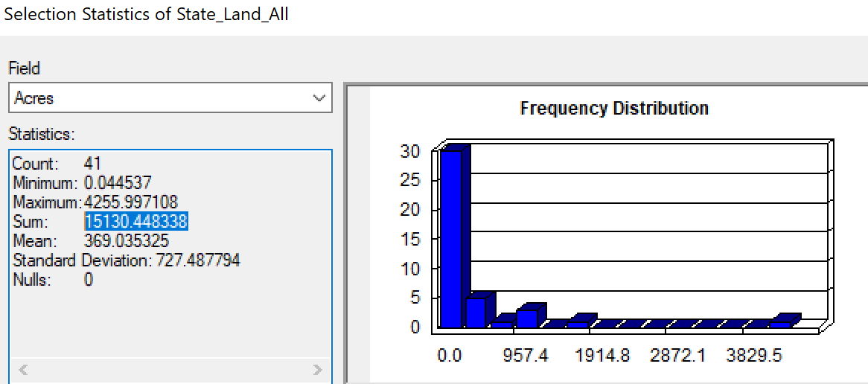

- how will our PILT payment be affected by less unorganized borough surrounding us?

- how will our Forest Service receipts be affected?

- are there other funding streams that could be affected?

- how much state land would Xunaa Borough be entitled to select?

- if state lands are unavailable within their proposed perimeter, are they allowed to select lands at large/adjacent? My concern is selecting state lands within the City of Gustavus.

I also looked at watersheds. Our watersheds are imperfect as until the lidar, we had poor elevation data, which drives how water drains down hill. Regardless, the lines of the proposed borough leave most of our watersheds intact. As the upper watersheds are also in the park in Wilderness, I think we have layers of protection, but it was a concern I wanted to look at.

I'm still curious how the 1% sales tax in the outer lands/waters will be collected and how it will be applied. Any concerns to fish box tax?

My gut feeling, it leaves Gustavus screwed for the future of borough building, but short of not knowing the financial implications, it doesn't feel like the end of the world to maintain the status quo. I also question the level of support when it goes to vote within the borough boundaries.

Thanks, Whitney

